Fact Sheet

HTSI ClickBill

Packaging

For

Department of Veterans Affairs Medical Centers (DVAMC)

Under

PlanetGov PCHS-II #

June 12, 2002
Introduction

This document describes the products and services provided to the Veterans Affairs for the HTSI ClickBill application. This document covers the following topics.

- Background
- HTSI ClickBill Description
- Pricing

Background:

Healthcare Technology Solutions International (HTSI) developed the Veteran Affairs version of the HTSI ClickBill application at the Wilkes-Barre DVAMC as part of a coding services contract. In general, HTSI ClickBill contains four data analysis and reporting applications, a Microsoft Access database application, and scripts to extract billing and patient encounter information from VISTA. These applications and scripts were developed over a one-year period to help the Wilkes-Barre DVAMC and HTSI convert disparate data into meaningful information for the purpose of improving efficiency, revenue, and compliance. The following matrix shows the contributions HTSI ClickBill made in achieving the revenue and compliance objectives of the coding contract: The HTSI ClickBill contribution is measured from “+” for a minor contribution to a “++++” for a major contribution in achieving the results.

+
43%-55%
Provider Coding Accuracy
+
Doubled 99213 %
Provider Documentation
++++
Compliance Efficiency
++++
Billing Dept Efficiency
++++
52% to 97%
% Billable Records Coded
+++
344 to 3412
Average Claims Per Month
+++
68 to 35
Average Processing Days
++
$2.9M – $6.0M
Estimated Revenue 2001-2002
+++
1:3
Contract ROI
HTSI ClickBill

Change

Dimension
Means a tremendous increase but metrics are not available to estimate changes.
Based on the contributions accredited to HTSI ClickBill, HTSI was encouraged to offer this software on the PCHS-II contract to other DVAMCs in VISN 4 who are interested in a tool that will contribute to their revenue and efficiency goals.

HTSI ClickBill Description:

The components of HTSI ClickBill include the following: They are described based on the information needs that drove their development and based on actual examples of using them to achieve revenue and compliance objectives. Detailed technical information is available from Healthcare Technology Solutions International by reviewing or requesting information off the HTSI website at http://www.htsicorp.com/.

- Billing Application
- Provider Application
- Coding Application
- Compliance Application
- Access Data Base

Billing Application:

The billing application was developed to provide more accurate billing information than was available through the Wilkes-Barre Open Bill Report and to consolidate billing information for the Billing Department.

Outstanding Billing Report: Early in the coding contract, it was determined that 38% of the visits/procedures on the Open Bill Report were not billable. In reviewing the reasons not billable in the Coding Application, it was discovered that non-billable patterns existed with regard to certain stop codes and within the 17 reasons used to code non-billable records. In response to this problem, automatic filters and a DVAMC pre-review data entry form were created with the objective of reducing the percentage of non-billable records reaching the contract coders. As a result of these efforts, the percentage of non-billable records reaching the contract coders was reduced to 3 % for the month of March 2002. This saves the Wilkes-Barre DVAMC an estimated $319,000 per year in contract coding costs. The following table is an extract from the Billing Application showing the progress in reducing non-billable records that are submitted to the HTSI coders:

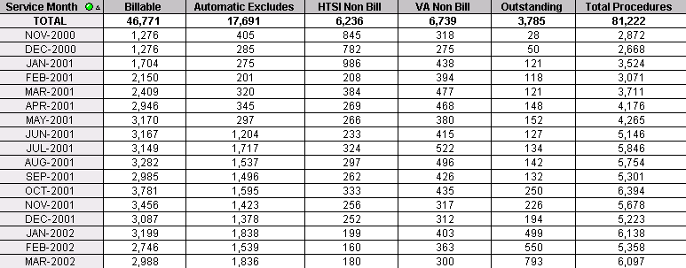

The mechanics of the outstanding bill report are based on extracting data from the DVAMC Open Bill Report, PCE Reports, patient encounter information, and from the HTSI database containing non-billable information. In the example above, automatic filters are used to identify 17,691 non-billable records, another 6,739 records were identified in the VA pre-review, and the HTSI coders identified 6,236 records. Of course the major benefit is based on the changes in categories of non-billable records over time. For example, in March the coders identified only 180 records and the Billing Application identified over 1,836 records automatically. Any DVAMC can easily conclude that the combination of reducing contract costs and increasing efficiency associated with not using professional coders to code non-billable records will more than pay for the cost of the software. This is true even if the HTSI database is not implemented.

Coding Report: The Coding Report is produced to identify the records to be reviewed by the VA and then coded by the HTSI Contract Coders. The print out produced is sequenced by stop code and assigned to coders to maximize the proficiencies the coders have with certain specialties and ancillary procedures. The individual sheets provide space for the VA staff to enter pre-review information and for the coder to indicate they have completed the record. Finally, different color sheets are used so the VA staff and the HTSI staff can readily identify different treatment facilities (Wilkes-Barre, Allentown, Sayre) and special interest coding categories (specific stop codes, time frames, etc). The net result of this report is increased efficiency and an audit trail to ensure the records are completed and coding is not duplicated. The data completed on the coding sheets is fed into the applications described in this fact sheet. The following graphic shows the headings of the Coding Report:
Division
June 12, 2002
Stop Code/ Iter
SSN
Date of Care
Provider
Stop Code Description
Bill No
Status
(Age) Patient

Consolidated Billing Report: The Consolidated Billing Report is produced by automatically consolidating the patient office visit with associated procedures based on date of service. Claims on the Consolidated Billing Report are included when the coding is complete for the office visit and all the associated procedures. The billing number (K-Code for the Wilkes-Barre DVAMC) and the K-Code suffixes automatically assigned by the Billing Application are provided in sequential order on the consolidated billing report. This allows the Billing Department Staff to efficiently file a claim in one complete procedure as opposed to the incremental process involving individual coding sheets and multiple changes to a patient claim.

Provider Application:

Almost all DVAMCs envision the potential benefits of improving provider documentation to reflect the complexity of healthcare actually provided, and to reduce the number of non-billable records due to insufficient documentation. To improve provider documentation and coding accuracy, many facilities have provided in-house training sessions or have contracted out for training and/or compliance audits. Because these training sessions and audits tend to be general in nature, and they are not provided on a continuing basis, the results usually fall short of expectations for improving revenue and compliance. Often, without focused information on individual performance, the providers are never aware of their specific deficiencies and therefore changes to adequately document the quality of care provided and to improve revenue are never implemented in their notes. The Provider Application, when used in conjunction with the HTSI coding database, overcomes the lack of specific information by providing specific information on every provider associated with third party insurance claims. The Provider Application profiles every provider with third party claims with regard to the percent coding accuracy and the percentage of non-billable records. The software also profiles the use of CPT and diagnosis codes for each provider. Due to the sensitivity of showing individual provider results, the following examples are limited to examples concerning the use of specific CPT codes and the aggregate reasons for non-billable records.

The below graph shows a dramatic turn around as a result of using our problem focused approach with regard to the use of CPT codes 93000 and 93005. In the graph, the correct behavior is for providers to code a 93000 instead of a 93005. The 93000/93000 in the graph represents that the provider and the HTSI Coder coded the record accurately as a CPT 93000. Conversely, the 93005/93000 indicates the provider coded it as a 93005 and the HTSI coder changed it to the correct code of 93000. As you can see, armed with the ability to track the use of these codes, the training that the Wilkes-Barre DVAMC provided in April dramatically changed the coding accuracy of the providers. Not only are the codes more accurate, but also the 93000 code provides more revenue for the facility. The Provider Application uses “and” and “or” relationships with any combination of CPT and diagnosis codes so the Wilkes-Barre DVAMC can look up any conceivable combination. This information provides a problem-focused approach to make policy changes and provide education to the right group of providers or to an individual provider. The below chart can be provided through the use of the HTSI coding data base for continuous analysis or through our compliance database for periodic audits. The software is also capable of extracting information from coding tools that capture and maintain two sets of codes from PCE – those captured at checkout and those that are recoded using a coding tool or a professional coder.

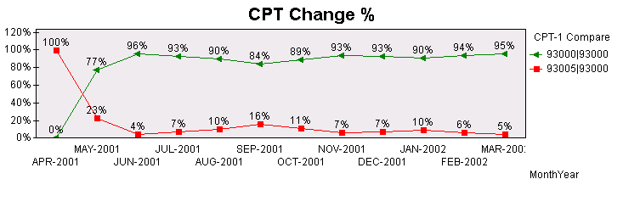
The following pie chart provides the overall percentages for the reasons for non-billable records. This analysis requires the use of the HTSI coding database for a 100% audit or the use of our audit database if a DVAMC wants to only conduct periodic audits.

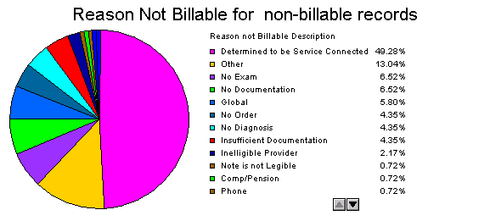

Coding Application:

The coding application follows the same concept of the Provider Application. Instead of profiling provider coding accuracy, the coding application supports the profiling of individual coder accuracy and productivity. Other attributes of the Coding Application are the ability to track coder productivity by the type of records coded and the profiling of the coding changes through a series of audits.

Compliance Application:

The Wilkes-Barre DVAMC, and VISN 4 compliance plans require periodic audits to determine coding accuracy and compliance with billable records. The Compliance Application allows the Wilkes-Barre DVAMC to automate the data collection and reporting by utilizing customized Microsoft Access data entry forms and combining information from the Coding, Provider, and VISTA applications. The application is specifically designed to profile coding accuracy and compliance over time. The ad hoc feature of the application allows the analyst to profile coding accuracy by stop code, provider name, coder name, record type, CPT code, diagnosis code, time frames, or any other dimension contained in the applications described above. The below is a pivot table that examines compliance by stop code for non-billable records with the reasons not billable as “no documentation” and “no diagnosis”. A similar pivot table is available for providers. The provider table is not shown due to the sensitivity of provider information.

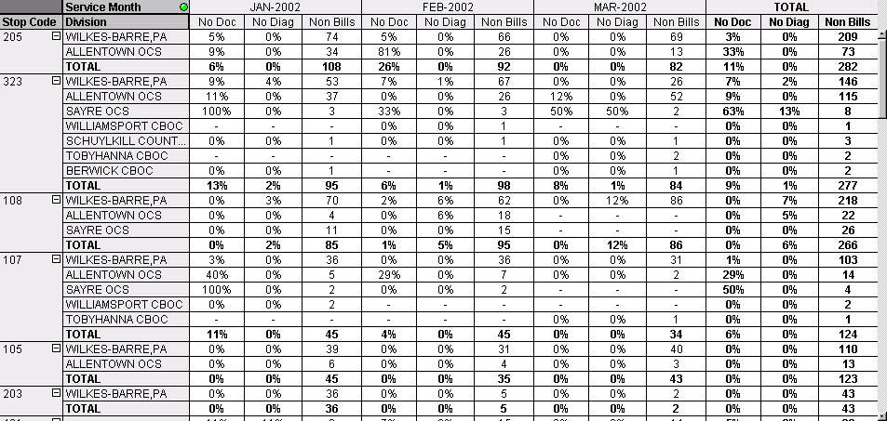

HTSI Access Data Base:

The reporting requirements under the coding contract required data that was not available in the standard VA information systems. The majority of the requirements included coding and auditing data that supported the validation of coding services performed and the comparative analysis of coding accuracy and billable/non-billable records over specified time periods. In response to these requirements, a customized HTSI data entry application using standard Microsoft Access database tools was created to capture and store this data. Over a one-year period, the database evolved as a source of coding and billing data that is combined with data automatically extracted from the Wilkes-Barre VISTA system to provide the information used for the above applications. Duplicate data entry of CPT codes, diagnosis codes, and patient identification information into PCE and the coding database is required to monitor data entry quality as specified in the coding services contract. If a DVAMC does not desire to monitor data entry quality, then the data can be extracted from PCE using the Coding Application to capture the checkout code and any change resulting from using professional coders, a coding tool, or review by the Billing Department. This extraction can also be accomplished by capturing information from coding tools that produce a database or have any type of export capability into databases, text delimited files, or Excel.

The Access database includes 15 forms and 19 tables that support the entry and storage of coding and auditing information. The below screen capture shows the main forms used to enter outpatient and inpatient data. The database was developed and maintained on-site at the Wilkes-Barre DVAMC. Future versions will provide for a Web based option where the only onsite requirement is a standard Web browser (Explorer, Netscape, etc). The forms and tables are updated to support cost and data changes under multiple year coding contracts.

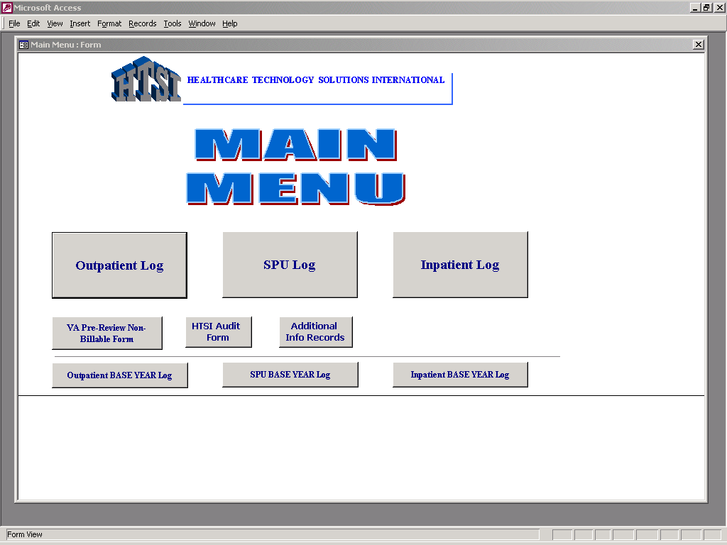

The below screen capture is the main form used for capturing outpatient coding information:

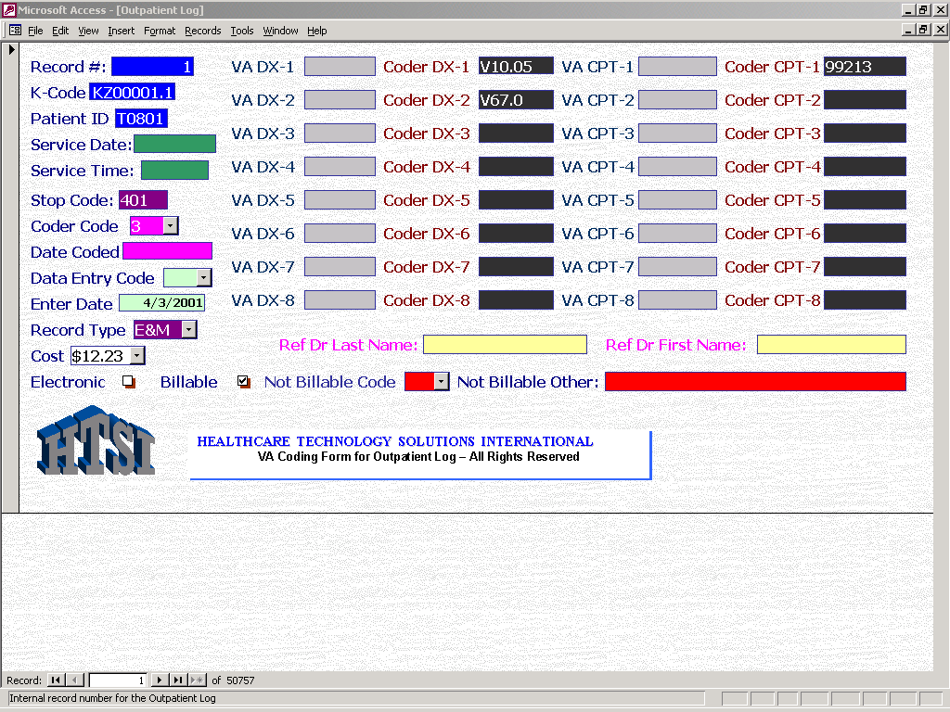
Pricing:

The HTSI ClickBill application includes the licenses for the applications described above and the Access database forms and tables for five users per DVAMC. Pricing assumes the DVAMC will use the VA enterprise license for Microsoft Access. The prices and supporting services are included in the below tables:

HTSI ClickBill - Individual DVAMC - $24,999

Includes:
HTSI ClickBill Licenses for 5 Users
Billing Application
Provider Application
Coding Application
Compliance Application
HTSI Access Coding Data Base Application
On-Site Installation
Half Day On-Site Training Session
HTSI ClickBill Documentation
ClickBill Users Manual
DVAMC ClickBill Computer Security Plan
DVAMC ClickBill Contingency Plan
DVAMC ClickBill Compliance Plan
DVAMC ClickBill Data Requirements Plan
One Year Support for Data Extraction Scripts, Access Database and Applications

HTSI ClickBill - VISN Value Pack - $22,500 Per
Facility Plus Free License for VISN Headquarters (Requires a Minimum of 5 Facilities)

Includes:
HTSI ClickBill Licenses for 5 Users
Billing Application
Provider Application
Coding Application
Compliance Application
HTSI Access Coding Data Base Application
VISN Revenue Analysis Package
On-Site Installation
Half Day On-Site Training Session
HTSI ClickBill Documentation
ClickBill Users Manual
DVAMC ClickBill Computer Security Plan
DVAMC ClickBill Contingency Plan
DVAMC ClickBill Compliance Plan
DVAMC ClickBill Data Requirements Plan
One Year Support for Data Extraction Scripts, Access Database and Applications

Maintenance - $5000 Per Facility for Individual DVAMC and VISN Value Pack

Coding Services – HTSI ClickBill is free of charge with one-year HTSI coding contract to code all billable DVAMC third party collection claims. A rebate for the cost of HTSI ClickBill is given to a DVAMC if they purchased HTSI ClickBill prior to coding contract.

Services – Services are also available for programming, analysis, data entry, Web development and records administration – Contact HTSI for further details at (830) 606-4918 or www.htsicorp.com.

