HTSI

PlanetGov/HTSI Standard Technical Proposal for Coding Services
Submitted February 28, 2002

Provided for Requirements under BPA N62645-02-A-0011

Business Case
Revenue Increases
Insurance
Budget
Cost Savings
Improved Quality
Compliance
Efficiency
Personnel
Costs
Contract Cost
Overhead
(+)
(-)
ROI
(=)
PlanetGov/HTSI Components and Services are designed on a positive return on investment

Last Edited August 13, 2002

TABLE OF CONTENTS

1 Introduction: 4
2 Problem Statement: 5
3 PlanetGov/HTSI Goals For MHS Coding Projects: 8
4 PlanetGov/HTSI Services to Meet Objectives 8
4.1 Process Reengineering: 8
4.1.1 Gap Analysis: 8
4.1.2 Process Reengineering Business Case: 9
4.1.3 HTSI ClickBill Application: 9
4.2 Purpose of Coding Services: 9
4.3 Coding Services 9
4.3.1 Coding Round Table Sessions: 10
4.3.2 Coding Credentials: 10
4.3.3 Coding Tests: 10
4.3.4 Assignment of CPT and Diagnosis Codes: 10
4.3.5 Coding Reviews: 10
4.4 Data Entry: 11
5 Education: 12
5.1 Purpose of Provider Education: 12
5.2 Provider Education Services: 12
5.2.1 General Education Requirements: 13
5.2.2 Classroom Sessions: 13
5.2.3 Small Group Training: 13
5.2.4 Individual Provider Training: 13
6 Data Base Application: 14
6.1 Purpose of Data Base: 14
7 Data Analysis: 15
7.1 Purpose of Data Analysis: 15
7.2 Data Analysis Services: 15
7.2.1 Data Analysis Software: 16
8 Reporting: 16
8.1 Reporting: 16
8.1.1 Standard Reports: 16
8.1.2 Ad Hoc Reports: 17
9 Records management 18
10 Data Entry: 19
11 Security and Confidentiality: 19
11.1 Security - Staffing: 19
11.2 Computer Security: 19
11.3 Confidentiality and Non-Disclosure: 19
12 Compliance Plan 20
12.1 Information Definitions and Principles: 20
12.1.1 Definition of Information: 20
12.1.2 Guiding Principles for Quality Improvement: 21
12.1.3 Data Collection As By-Product Of Work Performed: 21
12.1.4 Use of Statistical Process Control Software: 21
12.1.5 Use of Existing Data From Existing Data Repositories: 21
12.1.6 Collection and Analyzing Data on the WWW: 21
12.1.7 Aggregation of Information: 22
12.1.8 Ensure Front-Line Activities Get First Chance at Problem Solving: 22
12.1.9 Control Causes of the Problem Instead of the Symptoms: 22
12.1.10 Fail-Safing – Preventing Problems Before They Occur: 22
12.1.11 Self Inspection: 22
12.1.12 Process Improvement Training: 22
12.1.13 Process Orientation: 22
12.2 Factors Considered in Selecting Coding Metrics: 22
12.3 Metric Descriptions: 23
12.3.1 Records – 95% Coding Accuracy: 23
12.3.2 Responsive – Filing Claims Within 14 Days of Service Date: 23
12.3.3 Service – Rating of 4.0 on a Scale of 5.0 23
12.3.4 Claim Identification – 90%: 23
12.3.5 Consistency Among Coders < 5%: 23
12.3.6 Outpatient TPC Revenue – > 100% Increase: 23
12.3.7 Compliance – 98%: 23
12.3.8 Data Quality - < 5% Error Rate: 24
12.3.9 Data < 5% Variance Between Systems: 24
12.3.10 Denials < 10% of Claims Submissions: 24
12.3.11 Provider Documentation Completion < 7 Days: 24
12.4 Quality Process: 24
13 Data Analysis and Reporting: 26
13.1 HTSI CLICKBILL APPLICATION: 26
13.2 Sample HTSI ClickBill Reports and Queries; 31
13.2.1 Sample Clinic Report: 31
13.2.2 Sample Report ER Visits: 33
13.2.3 Example Provider Report: 33
13.2.4 Sample Queries: 34
14 Key Personnel: 35
14.1 Continuity and Quality of New Hires: Revise to make MHS specific 36
15 references: 37
15.1 Wilkes-Barre DVAMC: 37
15.2 Assistant Secretary of Defense, Health Affairs: 39
15.3 Integrated Outcomes: 39
15.4 Wilford Hall Medical Center: 39
15.5 Wilford Hall Medical Center: 40
15.6 Electronic Paper Solutions 40
16 Sequence of Events: 40
17 point of Contact for Technical Proposal: 40

INtroduction:

Please refer to the attached pricing proposal if you are receiving this technical proposal in response to your task order under the PlanetGov BPA for coding services BPA# N62645-02-A-0011. If you are reviewing this technical proposal, and it is not in response to a request for proposal, then you may request pricing from Healthcare Technology Solutions International (PlanetGov/HTSI) at http://www.htsicorp.com./

This technical proposal is based on providing coding services and products to evaluate and improve information common to the revenue process for most MHS facilities. The revenue process and the data collected are detailed at appendix A. A sample study using PlanetGov/HTSI coding services and products are to improve third party revenue is provided at Appendix B. The study and HTSI ClickBill application come as value adds to our coding services. As a result we are able to address the main objectives of any MHS facility to: (1) increase third party revenue; (2) improve coding accuracy and compliance, and (3) documenting the actual complexity and quality of patient care. Specifically, our total coding solution allows the MHS customer to accurately predict and measure the revenue and compliance percentage gains in seven components of the revenue cycle where we will increase the revenue of an MHS facility. These components include:

- Registration;
- Appointment Scheduling and Admission;
- Patient Encounter and Provider Documentation;
- Coding;
- Billing and Claims Follow-Up;
- Data Analysis and Decision Support System; and
- Process Improvements

Please refer to Appendix A for the details on the methods we use to evaluate the entire revenue process as part of our coding services.

In addition to the main objective of improving revenue, our team adds the following value:
- CME accredited education for providers and other staff members associated with the MHS revenue process. This allows providers to get CME credits on a quarterly basis. Based on the size and attendance at a MHS facility this could be $20,000 to $200,000 in savings. As you will see later, this also has a dramatic effect by improving the quality and completeness of documentation required for a billable claim.
- Within the cost of the contract, we provide16 hours of ad hoc report development per month to the MHS facility staff to customize the HTSI ClickBill application and Provider application described under the reporting section of this report. This represents a significant dollar value over the life cycle of the contract and allows MHS facility staff to obtain meaningful information without programming skills.
- The Contract includes bringing in the leading consultants in the country with regard to coding compliance, billing, legal and data analysis applications.
- We accomplish a business case in the first 60 days of the contract that validates our return on investment and provides a focused approach to improving revenue in the shortest possible time. For example, at the Wilkes-Barre, VA where we have coded and entered 80,000 records in their billing system, they recently experienced the highest revenue collection month in the history of the facility. Our consolidated billing report has almost entirely done away with the thousands of claims forms that used to clutter their office. For the MHS facility, this allows program managers to justify the budget for our services based on ROI. This is an important attribute considering the austere funding often faced by MHS facilities.
- A Web Library is provided as part of our services. This will allow PlanetGov/HTSI and the MHS facility to post key documents, compliance plans, performance metrics, and individual provider statistics on coding accuracy and frequency of non-billable records. This capability is provided under a teaming agreement we already have with the Department of Health Affairs. This provides easy access for MHS facility staff and is so documents and reports are current and controlled in a secure environment. Please refer to http://www.htsicorp.com for details regarding knowledge management and the Web Library.
- Our software applications provide many benefits beyond coding and third party collection analysis. For example, we have already proven we can load MHS and identify the chronically ill patient population and provide statistics by diagnosis, visit frequency, claims history, clinic usage, and look up capability for the clinical notes maintained as part of the billing process. The benefits include reduced time in gathering data for clinical studies, determining best practices, and information that may lead to improved quality of care.

Problem Statement:

The following problem statements are ones that are common to MHS facilities. We conduct a study at each facility to see if these problems exist. Based on the results of the study, we work with the facility to maximize the return on investment by attacking the problems that exist for that facility. Most MHS facilities continue to face financial challenges with budget shortfalls and have difficulty in obtaining and maintained the coding services that are key to describing the relationship between the complexity of care and the funds required to provide a best practice environment. Based on previous studies, the following problems need to be solved in order to maximize revenue, justify resources based on the complexity of care and insure compliance with DoD, HCFA, and insurance company payment guidelines.

- The identification processes of determining what patients have third party insurance is a problem in a MHS facilities that do not have the staffing to interview patients and research insurance benefits. The belief is many patients who have third party insurance are never identified and MHS facility never gets reimbursed for the care given to these patients. The identification problem is multifaceted with regard to establishing responsibility, training, collection of insurance information, and patient convenience associated with possible changes in point of service (POS) procedures.
- Documentation problems are prevalent in the identification of the patients with third party insurance and in documenting the care given to the patients. The documentation of the care results in decreases in the reimbursement rate and potential legal and certification issues. The belief is lots of care and diagnostic services are provided but not documented or the documentation cannot be found. Use of automated documentation tools can be problematic based on the lack of knowledge on ease of use, accuracy of the billing code, and ability to capture required documentation. Efforts in the MHS to provide pick lists for diagnosis codes and assistance for leveling E&M codes still require an expert coder to insure any probability that the diagnosis’s and CPT codes are accurate enough to result in meaningful information for best practice decisions and clinical studies.
- The coding of medical records remains a problem as long as many providers and clinic support staff are entrusted with entering codes into the Ambulatory Data Module (ADM), the Composite Health Care System (CHCS) and the Third Party Outpatient Collections System (TPOCS). Although solutions exist to allow providers the on-line entry of a code, it does nothing to help them select the appropriate code based on the care provided and what got documented in the patient record. Historically, coding issues are further complicated with regard to the timely updating of coding software to reflect the changes in codes that occur annually. With regard to billing, a pattern of coding inaccurately can lead to repayment of money to the insurance companies and/or fines and penalties. The following table is an example of the number of changes by MEPRS description in a MHS facility.

Coding Accuracy by MEPRS Description
MEPRS Description | EM Codes Evaluated | No Change | Levels Up | Levels Down | DX-1 Changes | DX-2 Change | DX-3 Change | DX-4 Change
 | 65 | 30 | 18 | 14 | 27 | 30 | 16 | 5
CARDIOLOGY CLINIC | 3 | 1 | 2 | 0 | 1 | 0 | 0 | 1
COUMADIN CLINIC | 9 | 9 | 0 | 0 | 7 | 9 | 1 | 0
EMERGENCY MEDICINE | 7 | 2 | 3 | 2 | 0 | 5 | 4 | 0
GENERAL SURGERY CLINIC | 12 | 3 | 2 | 6 | 4 | 2 | 0 | 0
HEMATOLOGY | 5 | 2 | 1 | 2 | 0 | 1 | 1 | 1
INTERNAL MEDICINE | 12 | 6 | 3 | 2 | 3 | 3 | 6 | 3
OBSTETRICS CLINIC | 1 | 0 | 0 | 0 | 2 | 1 | 0 | 0
ONCOLOGY | 4 | 4 | 0 | 0 | 4 | 1 | 0 | 0
ORTHOPEDIC CLINIC | 3 | 0 | 1 | 2 | 2 | 2 | 0 | 0
PRIMARY CARE CLINIC | 8 | 2 | 6 | 0 | 2 | 2 | 2 | 0
UROLOGY-APV | 0 | 0 | 0 | 0 | 2 | 3 | 2 | 0
UROLOGY CLINIC | 1 | 1 | 0 | 0 | 0 | 1 | 0 | 0

- Records management is a significant challenge since many MHS patients are seen at other DoD facilities. Due to understaffing in most MHS Records Departments and the problems associated with transporting medical records between multiple facilities, many of the chronically ill patients are hand carrying their records. A high percentage of these older patients are also the ones most frequently billed for Third Party Collection. From a billing compliance perspective, a problem is created if the record is not available for coding, verifying proof of service, coding accuracy, or verification of medical necessity. It is not uncommon in MHS facilities to find that over 30% of the records were not available as proof of service for billed claims.
- There are fewer billable visits in TPOCS when compared to the number of kept appointments recorded in the CHCS appointment scheduling system and ADM. This is resulting in loss of resources through inability to officially record the volume and complexity of care provided.

MHS facility info Top Ten Patients with Missed Billing Opportunities

Patient Number | Visits Not In TPOC | CHCS Visits | Visits in TPOC | Visits in ADS
 | 117 | 324 | 260 | 332
15 | 11 | 28 | 17 | 22
21 | 8 | 0 | 5 | 13
22 | 7 | 16 | 9 | 9
82 | 6 | 2 | 2 | 8
29 | 6 | 10 | 4 | 8
6 | 5 | 6 | 1 | 6
9 | 5 | 7 | 2 | 5
44 | 5 | 13 | 8 | 11
39 | 5 | 18 | 13 | 17
1 | 4 | 9 | 5 | 8

- Although the Military Health Service (MHS) has an integrated clinical system (CHCS) many MHS facilities do not have an automated capability to reconcile TPOCS information with clinical information contained in CHCS. Standard reports are available in each system but are often useless due to data quality problems or they do not contain the desired information. Although both systems have an ad hoc capability, the difficulty of using them often makes information unavailable to someone with limited programming skills. Even with these skills, the poor data quality prevents any degree of confidence that the data meets the definition of information (accurate, relevant, complete, and timely).
- Poor data quality is pervasive throughout the process of collecting, coding, and reporting patient information in most MHS facilities. Specific problems in TPOCS include variations in the same insurance company name, provider names, and provider numbers. The poor quality of data inhibits managers from obtaining the information required to make decisions or to select the best decision among possible alternatives.
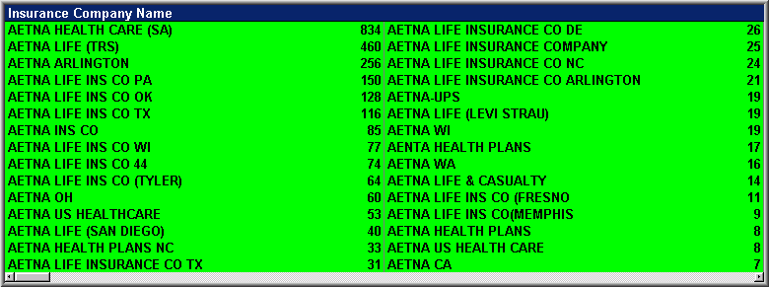
- There are a number of problems with the other health insurance (OHI) databases in some MHS facilities. The billable data in CHCS is out of date and the billing data may be unreliable. In a study we conducted in a large MTF we found CHCS billable data to be less than 50% accurate when compared to what ended up actually billable in TPOCS. When looking at TPOCS, there may be a problem in combining data from the tables used for ad hoc reports. For example, you may not be able to combine diagnosis, patient demographics, and payment data within the same ad hoc report. Finally, the decision support system is often hampered by the lack of systems support and efficient tools to extract, combine, and report information required for comparison between CHCS and TPOCS data.
- There may be numerous inefficiencies in the billing department with regard to auditing and consolidating procedures and office visits on the claim forms. Auditing individual claim forms is often limited to looking up the information in TPOCS and printing out one claim at a time. This was inefficient and provides no back up when TPOCS is off line. Because there was no interface between CHCS and TPOCS, there was no way of efficiently consolidating billing information on one consolidated bill to the insurance company. This causes significant difficulties in the follow-up process due to the requirement to reconcile multiple procedures and office visit information with the insurance company.

PlanetGov/HTSI Goals For MHS Coding ProjeCtS:
The goals for each MHS project are to provide process improvements and solve any or all the problems that may exist at a MHS facility. Solving these problems meet the typical MHS facility goals of: (1) improving coding accuracy and provider documentation; (2) maximizing the effectiveness and economy of the billing practices, (3) improving organizational policy development, decision making, management and administration, and (4) improving the effectiveness of management processes and procedures. Typically solving these problems will also significantly improve MHS facility’s third party revenue depending on the size and complexity of the MTF facility. The overall outcome is a business case that justifies changes based on return on investment. The following are some of the objectives common to most MHS facilities:
- Provide the capability to identify patients for collection of third party insurance. The process is directed at improving identification and reporting through all phases of the revenue cycle to include registration, appointment, point of service information collection, documentation, coding, filing claims, claims follow-up, utilization review, and auditing; (see Appendix A for revenue process plan for specific details on processes, data collected, and metrics)
- Provide accredited continuing medical education to providers to improve documentation that leads to improved coding accuracy and revenue by: (1) documenting the complexity of care actually provided (more revenue per claim); and (2) reducing the number of un-billable records (greater volume).
- Provide certified coders and analysis support to improve coding, identify billable patients, achieve compliance, and ultimately significantly improve revenue.
- Establish an automated process and data analysis tools to reconcile differences and improve data quality with respect to data in CHCS, ADM and TPOCS;
- Add staffing, establish new processes and install the HTSI ClickBill application to resolve the workload requirements and inefficiencies in the Billing Department;
- Provide continuous improvement throughout the revenue cycle by establishment of metrics, training, and implementation of a statistical process control processes;

PlanetGov/HTSI Services to Meet MHS Objectives
The following are the services we provide to meet the objectives of improving third party revenue and compliance throughout the revenue cycle:

Process Reengineering:

Gap Analysis:
PlanetGov/HTSI does a gap analysis from the as is state of the current process for identifying third party reimbursement to the “vision state” designed to maximize efficiency and the amount of reimbursements. This includes a mapping of the patient’s flow through the system to include registration, appointment, collection of information at POS, documenting services, coding, filing for reimbursement, claims follow-up and auditing (See enclosed fold-out contained in Appendix A) This process does not delay the coding of records or the day to day processing of claims. .

Process Reengineering Business Case:
Based on the GAP analysis, PlanetGov/HTSI provides a business case that provides the projected return on investment associated with making recommended changes. The business case will be a model allowing variance analysis based on implementing specific recommendations and based on percent changes in efficiency. It is the focal point to best determine the use of the staff and products PlanetGov/HTSI provides to the MHS facility. It also allows us to address any differences in philosophy at the beginning of the contract.

HTSI ClickBill Application:
The prototype for the HTSI ClickBill application was developed using the experience of extracting data from the MHS facility information systems to include CHCS, ADM, TPOCS, and Excel Spreadsheets. This application allows us to combine disparate data and make it into useful information that will dramatically improve insurance identification in the following ways. Many of the charts and tables in this document and the attached study were generated using the HTSI ClickBill application.

Comparison of CHCS and TPOCS Data:
We will compare CHCS data to TPOCS data for a number of reasons. There are two specific comparisons we will use to compare data for the purpose of insurance identification. First, we are going to match the appointment scheduling data on patients from CHCS with the billing information on patients in TPOCS to identify those patients who we successfully billed in the past. Once identified, we will identify them to our insurance specialists or MHS facility staff to make sure documentation requirements are met and to work with MHS facility staff too: (1) make sure an eligible provider for billing purposes sees them; or, (2) if appointed to a resident, the teaching physician sees the patient and provides the required documentation. The second reason is to determine the error rate in CHCS with regard to the “Billable” data field. We have a hypothesis that many military personal with dependants report insurance coverage in one location but fail to report this information in subsequent assignments. We will progressively build our HTSI ClickBill application so our insurance specialists or the MTF staff will have a look up capability to detect these patients. The first will be a look-up capability for most frequently used MTF referral facilities. The next step is to provide a look up capability for facilities within a facilities regional headquarters. For reporting purposes, it is a simple task for us to load this data in HTSI ClickBill and determine the changes in reporting insurance coverage and the associated revenue impact. Of course, the next step is to collect insurance data for all MHS facilities.

Purpose of Coding Services:
The overall purpose of coding services is to provide service throughout the revenue process to improve third party revenue and increase the facilities budget by: (1) ensuring the code assignments accurately reflect the complexity of care; (2) ensuring provider documentation is compliant with Government and insurance company regulations and payment criteria; (3) improving processes to identify billable encounters; and (4) to improve provider documentation.

Coding Services

The accurate coding of medical records is essential for reporting the care actually provided, getting paid and avoiding paybacks to insurance companies; and avoiding Government penalties. PlanetGov/HTSI will carry insurance to protect MHS facility and us from these repayments and penalties. This insurance requires that we use PlanetGov/HTSI certified coders with commercial expertise to code all inpatient and (or) outpatient claims. PlanetGov/HTSI will provide certified coders to code all the records submitted for third party insurance. In addition to meeting our insurance requirements, this eliminates any problems with compliance or delays associated with waiting for the records to be coded by MHS facility staff. The following are the specific coding services that will be provided as part of an PlanetGov/HTSI coding service contract:.

Coding Round Table Sessions:
Immediately after contract award, we schedule round table sessions with the coding and billing department to discuss process and coding philosophy. These sessions insure we are all on the same page with regard to MHS and local facility policies, coding philosophy, specialty exemptions, waivers, etc. At this point, we jointly code a sample of records with the MHS facility’s coding staff to detect differences in leveling, diagnosis selection and use of the 97 versus 95 coding standards. We also know the MHS has some requirements and codes that differ from common commercial practices and they will be resolved at this time.

Coding Credentials:
PlanetGov/HTSI will provide coders with the current credentials of a Registered Health Information Technician (RHIT) or a Registered Health Information Administrator (RHIA), or a certified Coding Specialist (CCS) or a Certified Professional Coder (CPC) or (CPC-H).

Coding Tests:
We test all our coders before they are hired. We develop this test jointly with our customers to make sure our coders are tested on the variety of specialties represented by that facility. The test results determine if we hire the coder and the education and auditing frequency required to correct any deficiencies. This approach insures we get the records coded accurately from the very beginning.

Assignment of CPT and Diagnosis Codes:
We will make the assignment of codes to identify the outpatient services (facility and professional) documented as part of the outpatient encounters contained in the appointment scheduling module of the Composite Health Care System (CHCS), the Ambulatory Data Module (ADM), and the Third Party Outpatient Collection system (TPOCS). We will insure the coding accurately reflects all of the patient’s diagnoses and procedures that apply to an outpatient encounter or inpatient admission through appropriate ICD-9-CM coding (diagnostic and procedural, current procedural terminology (CPT) and Health Care Financial Advisor common coding systems (HCPCS). We will evaluate the completeness and accuracy of coding diagnoses and procedures in accordance with official coding guidelines (Coding Clinics, CPT assistant, HCFA/American Medical Association (AMA), Ambulatory Patient Classifications (APC) in a simulated Medicare payment environment.

Coding Reviews:
All reviews will be conducted using MHS and HCFA guidelines and/or regulations. PlanetGov/HTSI is responsible for applying MHS rules where they are different from HCFA guidelines and/or regulations.

Coding Accuracy and Recommendations:
PlanetGov/HTSI will be compliant with the HCFA Correct Coding initiatives, ensure the accuracy of codes, and offer suggestions to improve coding accuracy and compliance for PlanetGov/HTSI and MHS facility staff.

Data Entry using MHS facility Data Collection Tools:
PlanetGov/HTSI will enter all coding information into the data collection tools (CHCS, ADM, TPOCS) provided by the MHS facility.

Coding Quality Reviews of PlanetGov/HTSI Coders:
All certified coders are tested before being hired using a coding test developed by our staff in conjunction with the MTF. They must pass with a score of 90% to be hired. For the first month of employment, 100% of the coders records are audited at the site where they work.. The test ensures they have basic coding skills for the specialties and type records coded by the facility and the 100% audit insures the coders have adapted to any local facility guidelines and the coding of the specialties they are assigned to code.

The PlanetGov/HTSI team audits our coders on a weekly basis. We pull three records per week for outpatient coders and 1 record per week for inpatient coders. We have learned through experience that it is better to use small samples on a very frequent basis. The logic is to minimize the time required to discover a problem. Most companies using similar statistical process control techniques follow the same philosophy. For example, Motorola does not want to discover they manufactured thousands of bad cell phones before they discover a problem so they do frequent audits using small samples. Similarly, we do not want to code thousands of records before we find a problem and have to recode all the records. This is a real big problem if the incorrect codes were used on claims already submitted to insurance companies for payment. Like our competitors, we used to do large audits once a month, but have determined that it is too risky. Additionally, our software automates much of the audit sampling, data analysis, and reporting process and we have eliminated the overhead one might associate with frequent audits.

Feedback on Provider Coding Accuracy and Documentation:
PlanetGov/HTSI will provide monthly feedback to the MHS facility regarding physician trends to include patterns of up-coding, down-coding, lack of medical necessity, codes reported but not supported by documentation, incorrect or inappropriate diagnostic or procedural codes, wrong types of E&M codes, incorrect principal diagnosis, incorrect principal procedures, and lack of identification of co-morbid condition and complications. PlanetGov/HTSI will use this information to provide recommendations for policy changes and for identifying topics for continuing education for providers and MHS facility staff involved in the coding, revenue, and budgeting process.

Coding Audit Report:
PlanetGov/HTSI will provide a report detailing the overall coding accuracy, the accuracy of individual contract coders, and a listing of the records and the associated coder and auditor codes. This report will be provided in hard copy and Microsoft Word format within 10 business days after the end of the auditing period. Interim checks on coding accuracy are available to our customers upon request by accessing the HTSI ClickBill application.

Coding External Audit:
PlanetGov/HTSI will provide a database capability and data entry support to enter the audit results from an external auditor. The comparisons and audit report will follow the requirements for internal audits plus the additional capability to analyze a series of three codes. The capability will exist to analyze what the coder coded, what the internal auditor coded, and what the external auditor coded. After receiving the data from the external audit, the report will be due in hard copy and Microsoft Word format within 10 business days

Data Entry:
PlanetGov/HTSI will enter all coding information into the data collections tools provided by the MHS facility – usually CHCS, ADM and TPOCS. PlanetGov/HTSI will provide the programming and data entry support to create and maintain a PlanetGov/HTSI provided database to compare and trend coding assignments for four levels of coding. The four levels to be compared include: (1) the codes assigned by MHS facility providers or coders; (2) the codes assigned by PlanetGov/HTSI Coders; (3) the codes assigned by PlanetGov/HTSI auditors; and (4) the codes assigned by the MHS/Government auditors. We track the data quality of all our data entry personnel and can equate the number of claims or dollar amount by data entry clerk. The following graphic is an example of the information provided to the MHS facility:
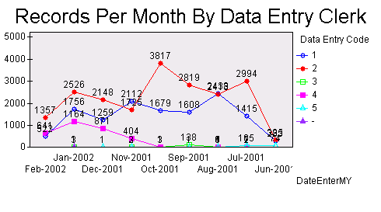

Education:

Purpose of Provider Education:
The purpose of provider education is to: (1) help providers improve their coding accuracy; (2) identify and train providers on documentation required for billable records; (3) improve documentation to reflect the complexity of care provided; and (4) reduce the number of non-billable records by focusing on specific provider, specialties, and provider problems.

Provider Education Services:
Based on the results of data analysis, continuing education will be given to providers regarding documentation and coding accuracy. The provider education will be delivered on the frequency described in the task order. The below graph shows a dramatic turn around as a result of using our problem focused approach with regard to the use of CPT codes 93000 and 93005. In the graph, the correct behavior is for providers to code a 93000 instead of a 93005. The 93000/93000 in the graph represents that the provider and the PlanetGov/HTSI Coder coded the record accurately the CPT as 93000. Conversely, the 93005/93000 indicates the provider coded it as a 93005 and the PlanetGov/HTSI coder changed it to the correct code of 93000. As you can see, armed with the ability to track the use of these codes, the training that took place in April dramatically changed the coding accuracy of the providers. Not only are the codes more accurate, but also the 93000 code provides more revenue for the facility. We create “and” and “or” relationships with any combination of CPT and diagnosis codes so our customers can look up any conceivable combination. This information provides a problem-focused approach to make policy changes and provide education to the right group of providers or to an individual provider.

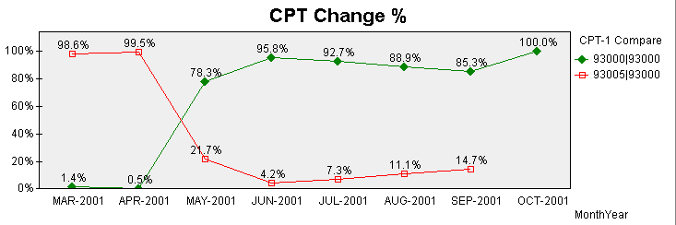

General Education Requirements:
In general, education will be problem focused based on the reviews of provider coding accuracy and documentation.

Presentations:
PlanetGov/HTSI will prepare a formal Power Point presentation and provide it to MHS facility 30 days before the scheduled presentation for review. The presentations will be supplemented with examples of provider notes from the facility. The presenter will be accredited and the classroom training will be accredited for continuing medical education (CME) credits for the providers and other staff of the medical facility.

Agenda:
The agenda for each education session will be submitted for approval 30 days before scheduled sessions. The agenda will include objectives, list of specific topics, and recommended attendees.

Record Keeping:
PlanetGov/HTSI will keep records on provider education. Specific provider information will include the provider name, specialty, course title, date attended, and the hours of education. The data will be stored in a database for the purpose of extraction into the provider application for analysis. This allows us to do a time series analysis of the efficacy of the education provided. Specifically, we associate the number of education hours with changes of coding accuracy over time.

Classroom Sessions:
The following are the objectives for the Classroom sessions for greater than 30 providers:

Provider Coder Accuracy Review:
The instructor will review of overall coding accuracy for primary CPT, diagnosis, and billable record percentages.

Documentation Requirements for Billable Visits:
Provide teaching physicians and residents with the specific documentation requirements required for a billable visit.

Coding of Evaluation and Management (E&M) Services:
The instructor will provide instruction and review of sample records for determining the correct levels for evaluation and management (E&M) services.

Improving Documentation:
The instructor will provide discussion and specific recommendations on improving documentation to adequately reflect the actual complexity of care provided. This will specifically address the key components of the provider’s note to include: chief complaint; history of present illness; review of systems; medical exam; past medical history, family and/or social history (PFSH); medical decision making; and examination. This training will be focused based on the problems identified in the provider analysis application.

Small Group Training:
Education sessions for small groups of less than 30 providers will be based on common problem areas or unique issues involving specific specialties. For example, problems with selecting the right ophthalmology codes would be addressed with a group session of Ophthalmologists. This training will include a review of the group coding accuracy and reasons for non-billable records.

Individual Provider Training:
The instructor will provide review and instruction for individual providers with a high volume of complex patients. The instruction will be focused using sample records completed by the provider.

Data Base Application:

Purpose of Data Base:
The purpose of the database is to add data required to analyze all the variables in the revenue cycle contained in the attached Revenue Process and Data Variables document. The new data added in the PlanetGov/HTSI database along with the extraction from CHCS, ADM, MHS facility ICDB, EMPRS and TPOCS provides the available information to profile providers, coders, insurance specialists, data entry clerks, insurance companies, specialties, patients, use of diagnosis/CPT codes, non-billable records, record types; or any other variable contained in the MHS facility data repositories and PlanetGov/HTSI databases.

A database application will be implemented and maintained for the purposes of creating data fields required for tracking coding changes, provider performance, and PlanetGov/HTSI performance. The database will support extractions of data from CHCS, ADM, and TPOCS for the purposes of capturing coding, provider, patient, and encounter data used for data analysis and reporting. The below screen capture is an example of the data base form we will use at MHS facility:

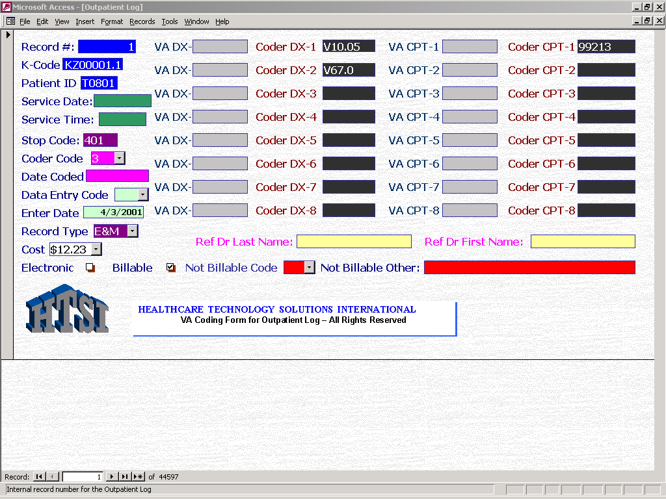

Database Software:
The database application is relational, supports ODBC connectivity, and allows Structured Query Language (SQL) look up. Software support includes, Microsoft Access, Sequel Server, ORACLE, Informix, or Sybase. The standard data base software we prefer for MHS facilities is ORACLE. The database includes the tables, forms, and data fields required to input data and store information that will be used for analyzing the following dimensions:

- Provider Documentation Accuracy
- Provider Coding Accuracy
- Coder Accuracy
- Data Quality
- Data Entry Accuracy
- Payment Profiles by Diagnosis and CPT codes
- Payment Profiles by Insurance Company
- Patient Profiles by Insurance Registration, Service Dates, Diagnosis and CPT Assignments, Insurance Company Payments and Patient Demographics.
- Specialty; i.e., Cardiology, Internal Medicine, Profiles

A complete listing of the variables included in the database is provided in the attached Revenue Process and Data Variables document.

Data Analysis:

Purpose of Data Analysis:
Disparate data from CHCS, ADM, and PlanetGov/HTSI database needs to be converted into useful information used for continuous quality improvement initiatives. The purpose of the data analysis software is to identify associations in the data that lead to revenue and quality improvements; and to allow the MHS facility to monitor performance against established revenue goals. To accomplish this, PlanetGov/HTSI will provide all labor, materials, transportation, software, and supervision necessary to analyze all the variables associated with the revenue process described in the attached Revenue Process and Data Variables document. The following are the specific functionality provided for the computer, software, and services support required for the data analysis:

Data Analysis Services:
PlanetGov/HTSI provides application software (HTSI ClickBill) and services to analyze, profile, report and make recommendations to continually improve the revenue and compliance process. For every record we code, we determine if the provider’s documentation supports a billable claim. We provide reports, analysis, and education to reduce the number of non-billable records. For example, the below chart summarizes the reasons coding entries were not billable for a large MHS facility. From here we can drill down to the record level and provide our customers with frequencies, provider name, data of service, specialty, provider information, or any other dimensions included in the PlanetGov/HTSI data base or extracted from the facility financial and clinical applications.
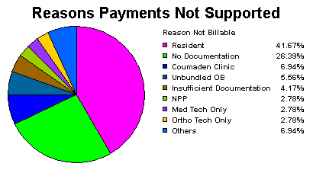
The next graph shows the percent of records PlanetGov/HTSI codes that are billable. After contract award in April, we worked together with our customer to dramatically change the billable percentage from 50% to 90%. This provides a tremendous cost savings to our customer since they will not be spending the time and effort to bill non-billable claims. We also provide education for our customers that allow them to improve their budgets when the MHS goes to reasonable charges where accurately documenting and coding the complexity of healthcare given will significantly impact the dollar amount of their budget. Also note that we can put in reference lines in our line charts to show goals for a particular dimension. In this case our goal is that 90% of what PlanetGov/HTSI codes are billable.
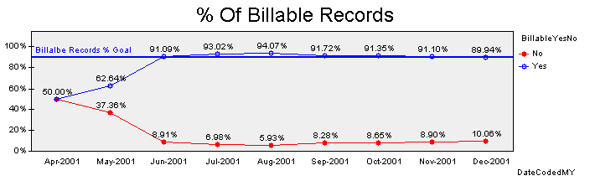

Data Analysis Software:
PlanetGov/HTSI will provide an On-Line Application Processing (OLAP) tool and training for analyzing and reporting data contained in PlanetGov/HTSI Data Base and the data extracted from CHCS, ADM, and TPOC. PlanetGov/HTSI will provide application development, training, and maintenance for MHS facility staff members who will be analyzing the dimensions described above under the database application. The functionality of this software is as follows:

- A comprehensive script language to allow extraction and loading of data from PlanetGov/HTSI provided database, CHCS, ADC, and TPOC;
- Extraction capability from ODBC, text delimited, and Excel files;
- A point and click interface to select any variable loaded from execution of the script to view its association with any other variable loaded in the application. For example, a click on a provider’s name would show the associations with his/her: (1) use and frequency of DX and CPT codes; (2) specialty affiliation; (3) patients seen with service dates; (4) insurance billings and payments; (5) reasons and frequency of non-billable documentation; or (6) association with any other variable contained in the database.
- A comprehensive capability to create objects to include: (1) line charts; (2) pie charts; (3) bar charts; (4) tables; (5) scatter charts; (6) pivot tables; (7) variable list boxes; (8) sheet tabs; and (9) text boxes.
- Common Windows like formatting features for objects, data, and text such as color, font size, number format, sheet layout options, etc.
- Mathematical Functions that can be used in load scripts and objects to include basic math functions, aggregation functions, descriptive statistics, numeric operators, string operators, logical operators, relational operators, and common financial functions.
- Ability for time series analysis to include line charts with reference lines for established goals; i.e., graphically plotting coding accuracy with a goal (reference line) of 95% accuracy.

Reporting:

Reporting:
PlanetGov/HTSI will provide standard reports and an on-line ad-hoc reporting capability as follows:

Standard Reports:
The following are the standard reports and the frequency with which they are prepared and delivered to the MHS facility:

Return on Investment Study:
An estimated return on investment study will be delivered 60 days after contract award and will be updated every quarter to reflect accrual of the revenue and costs, and the actual return on investment of the contract. The estimated return on investment will provide estimated revenue and cost changes from the baseline of the previous fiscal year. The analysis will specifically address the components of the revenue cycle described in the attached Revenue Process and Data Variables document. This report will include a hard copy in Microsoft Word format, an application using the analysis tool described above, and a financial model allowing “what if” analysis on the variables described in the revenue cycle.

Standard Provider Report:
The standard provider report will be provided monthly. It will be provided 10 business days after the end of the month. The standard provider report will profile the provider’s use of diagnosis and CPT Codes, and reasons why the provider note did not support billing and payment for third party insurance claims. The report will be sorted by provider name, specialty, and by diagnosis and CPT codes. The software will support input variables to analyze providers and specialties based on a minimum number of occurrences. For example, sometimes the analysis will be controlled to providers with at least 30 records coded for comparison, and on another occasion it will be controlled to at least one record coded for comparison. This report will also provide data on the most frequently changed diagnosis and CPT codes sorted by provider and specialty. This report will be provided in Microsoft Word format and will be supported by the data analysis provider application.

Standard Audit Report:
A written standard audit report will be delivered monthly with interim look-ups available upon request. It will be provided with 10 business days after the end of the reporting period. This report will contain the coding and data entry accuracy percentage for every coder and data entry person PlanetGov/HTSI uses for coding and data entry. If the MHS facility or any other Government agency conducts an audit this information will be combined with the PlanetGov/HTSI auditor’s information for third or fourth level comparisons and certification of accuracy. This report will be provided in Microsoft Word format and will be supported by the data analysis audit application.

Standard Billing Report:
The standard billing report will provide the totals for billed claims and payments on a monthly basis. This information will be sorted by provider, specialty, insurance company, diagnosis code, CPT code, and percentage of payments/billed. Zero payments will be analyzed to determine non-payment patterns by insurance company, diagnosis code, and CPT code. Processing times will be reported by total and by insurance companies for the following intervals:

- From patient service date to coding date
- From patient service date to billing date
- From patient service date to payment
- From coding date to billing
- From coding date to payment
- From billing date to payment

Ad Hoc Reports:
PlanetGov/HTSI will build four applications that support an ad hoc capability to drill down through the data to determine associations between the variables contained in the attached Revenue Process and Data Variable document. The four applications include:

- Master Ad-Hoc Report
- Provider Application
- Auditing Application
- Billing Application

In general, each application will include a point and click interface to drill down through the data loaded into the application. The data list is included in the attached Revenue Process and Data Variables document. The applications will also include the capability to create new objects as described in the On-Line Application Processing section of this document. For example, lets say someone is interested in determining how often a 99213 CPT code is under coded to a 99212. The analyst would go to the combination code list box and select the 99212/99213 combination indicating that the provider coded a 99212 and the professional coder coded a 99213. The selection would provide the total number of times this under coding occurred. With this selection active, the analyst can see the totals for each specialty. By clicking on the specialty with the highest frequency of under coded 99213s from the specialty list box, the analyst can see the list of the providers in that specialty with the highest frequency of under coded 99213s. From the provider list box, the analyst can select the provider with the highest frequency of under coded 99213s in the specialty and view a table containing the patient names, service dates and record numbers. These records can then be reviewed to determine common problems and can be used as examples for the education programs discussed later in this document. After training occurs, the Analyst can select a bookmark to determine how effective the continuous training is over time by viewing a line chart that trends the number and percentage of under coded 99213s by month.

Master Ad-Hoc Application:
This application will allow drill down on all the variables listed in the Revenue Process and Data Variables document. It is intended for senior executives of the MHS facility who have a need and interest in analyzing the total revenue cycle.

Provider Ad-Hoc Application:
The provider ad-hoc application allows the analyst to sort information by provider. It will support selections for specialties, diagnosis codes, CPT codes, reasons non-billable, and record look-up by patient name, record number, Social Security Number and service date.

Audit Ad-Hoc Application:
The audit application will be designed to drill down through diagnosis and CPT code assignments to determine the accuracy of the PlanetGov/HTSI coding. The application will include the ability to analyze individual coders, combination of codes, i.e. 99212/99213, use of specific codes, and the accuracy trend over time.

Billing Ad-Hoc Application:
The billing ad-hoc application will be designed to allow the analyst to drill down through billing and payment data to determine patterns of non-payment, average payments by diagnosis code and CPT codes, and associations with regard to the processing times described above. The variables include insurance companies, patient demographics, providers, provider type (resident, PA, nurse, technician, staff, etc), billing amounts, payment amounts, CPT codes, diagnosis codes, billing dates, write off codes, and payment dates.

Records management

Hard copies of the outpatient notes for billable encounters will be filed and maintained in accordance with the Government and commercial audit requirements for Government compliance (Medicare, Medicaid, and Military Health System) and proof of service.

For billable encounters, hard copies of provider notes and coder assignments are required for: (1) proof of service; (2) audits of coder accuracy and data entry; and (3) development of educational materials. This level of effort is required as long as provider notes are not automated and a significant percentage of patients are allowed to keep the only copy of their medical record in their personal possession.

All our database and data analysis applications contain an auto number field to assign a unique number to assign a unique number to each record. This number is used to look up notes that are filed in numerical sequence. This number can be cross matched with any variable in our databases and they are associated with all the database variables so information can be looked up based on the information available to the claims specialist or the analyst; i.e. patient name, SSAN, provider, etc.

Data Entry:

A lot of the coding functions require the entry of data into CHCS and ADM. The ability to continuously track the workload and data quality of data entry ultimately determines if information in reports and claims information is meaningful or useful in making the right decisions. All the PlanetGov/HTSI database applications capture the entry date and the data entry code of the person entering the data. PlanetGov/HTSI will internally audit the quantity and quality of data entry provided by the data entry personnel. PlanetGov/HTSI will also report data quality problems encountered while using CHCS, ADM, and TPOCS.

Security and Confidentiality:

Security - Staffing:
All PlanetGov/HTSI personnel will have background checks and will complete computer security, facility security, and fire safety training.

Computer Security:
All MHS information systems (systems, software applications, and networks) must be certified and accredited prior to deployment. To help ensure adequate security safeguards are in place as a system is being developed, PlanetGov/HTSI will follow DoD Instruction 5200.40, DoD Information Technology Security Certification and Accreditation Process (DITSCAP). PlanetGov/HTSI is experienced in applying security solutions to meeting DITSCAP Process and Air Force Certificate of Networthiness requirements. PlanetGov/HTSI will use an SSAA as a living document representing the formal agreement among the DAA, the CA, the user representative, and the program manager. The DITSCAP certification process was established as a DoD standard infrastructure-centric approach that protects and secures the entities comprising the Defense Information Infrastructure (DII). The set of activities presented in the DoDI 5200.40 DITSCAP standardize the Certification and Accreditation (C&A) process for single IT entities that leads to more secure system operations and a more secure DII. The process considers the system mission, environment, and architecture while assessing the impact of operation of that system on the DII. All PlanetGov/HTSI personnel will have background checks and will complete computer security, facility security, and fire safety training. PlanetGov/HTSI will develop a computer security and contingency plan for PlanetGov/HTSI provided computer systems and PlanetGov/HTSI maintained data.

Confidentiality and Non-Disclosure:
Information collected that may fall under the Privacy Act will be afforded the required protection and non-disclosure procedures. All individually identifiable health records will be treated with the strictest confidentiality. Access to records will be limited to essential personnel only. Records will be secured in locked areas and/or kept from access by unauthorized individuals when not in use. At the conclusion of the contract, all copies of individually identifiable health records will be destroyed or returned to MHS facility. Information that contains data about users, patients, team members, etc., will be protected in accordance with The Privacy Act 38 USC 5701, and 38 USC 7332. A pop-up warning and markings will be in-place on web pages or files that contain information that requires protection under this act. Any databases will contain the required warnings and the data will be protected accordingly. All personnel and users will not disclose this information without the approved consent of the affected individual(s).

OMB Circular A-130 reinforces the Computer Security Act requires Federal agencies to provide for the mandatory periodic training in computer security awareness and accepted computer security practices of all employees who are involved with the management, use, or operation of a Federal computer system within or under the supervision of a Federal agency, including contractors. Both DoD Directive 5400.11-R and the Privacy Act Program require a computer security-training program as a safeguard to protect data and system; availability, confidentiality, and integrity. DoD Directive 5200.28 identifies "Security Training," as a minimum requirement, "establishment of a security training and awareness program that will ensure all persons responsible for the AIS or information processed and/or maintained by the AIS, or all persons who access the AIS, are aware of proper operational and security-related procedures and risks." PlanetGov/HTSI will adhere to all these guidelines

Compliance Plan

PlanetGov/HTSI reviewed the data quality of the information systems used to access coding services and the Third Party Collection process. The process used was to determine the information required to perform coding and third party collection programs with regard to coding accuracy, maximizing revenue and conforming to documentation requirements and standards of conduct. Upon determining the information, metrics were developed to use in a continuous quality improvement program for a MHS facility. The following is the overview of the definitions of the information, recommended metrics, and the monitoring process. We will deliver an instruction manual within 60 days of MHS facility’s approval of our compliance plan. In addition to the training manual, two training sessions will be conducted within 60 days of contract award containing instruction on the continuous quality control process and the use of our data analysis software. This is one of the most important parts of the compliance plan since you cannot get there unless you know where you are headed. This portion establishes the successful end state (benchmarks) and the process to monitor the journey and achieve the desired result.

Information Definitions and Principles:
The intent of PlanetGov/HTSI is that the compliance plan will not just be another report put on the shelf; but rather a document that triggers an on-going process to improve the information required to access coding accuracy and the successful operation of the Third Party Collection Program. To accomplish this objective, it is important to understand the definition of information and have knowledge regarding the underlying principles used to improve information and the subsequent success of the program.

Definition of Information:

Data becomes information when it meets four characteristics: (1) timeliness; (2) relevancy; (3) accuracy; and (4) conciseness. Timeliness means the information is available before or at the time you need it to make a decision. In the case of Third Party Collection, information on compliance needs to be available before a claim is submitted. Relevancy means the information is appropriate for the process you are trying to control. For example, insurance carrier information has to be relevant to an individual carrier when trying to resolve a claim. Accuracy means the information is correct so reports and data lead to the right actions and decisions. For example, selecting the right office visit codes and DRGs impacts the revenue in Third Party Collections and compliance. Conciseness is a requirement for information to be useful without an extraordinary effort to sort and assemble the data. It is clear that MHS facilities need an application and plan for pulling together information in a simple and reliable format in order to direct resources to the most efficient attainment of the common MHS objectives defined earlier.

The information for success that needs to meet the above characteristics for information is described earlier in this report. This information includes:

- Patient Insurance Benefits and Carrier Information;
- Provider Documentation
- Coding and Compliance
- Identification of Billable Visits
- Claims Processing
- Records Availability
- Teaching Physician Guidelines
- DoD, HCFA and Insurance Coding Guidelines

Guiding Principles for Quality Improvement:

The guiding principles are provided for making decisions with regard to establishing, collecting and monitoring metrics to use as a basis for determining performance and for continuous quality improvement. The principles are also intended to establish metrics where the return on investment exceeds the effort and cost of collecting the metrics. Finally, the principles are designed so the accomplishment of the metrics is strongly correlated to achieving the revenue and compliance expectations of the Third Party Collection program. Specifically, the intention is to avoid goal displacement by ensuring the desired outcomes are a by-product of succeeding in meeting the metric benchmarks.

Data Collection As By-Product Of Work Performed:
To the extent possible, the data used for the metrics should be collected as a by-product of the work performed by providers of care, clinic staff, coders, and staff of the Third Party Collection Office. For example, the use of encounter documentation software would: (1) automatically provide service codes, (2) include pre-formatted text to meet teaching physician guidelines; (3) provide an interface to automatically transmit coding information to the Third Party Collection Office; and (4) be an on-line file for proof of service and review of treatment.

Use of Statistical Process Control Software:
Statistical process control and data analysis software should be used to plot data points and provide analysis based on the criteria set for the individual metrics. Doing statistical process control and data analysis manually is too arduous and will inhibit the process of evaluation and improvement. In most MHS facilities, the coding process benefits tremendously from software that improves the ease of analysis and automatic notifications of information required for maximizing revenue, meeting compliance, and to maintain specified standards of conduct. The MHS would benefit from these tools throughout all clinical and information activities performed.

Use of Existing Data From Existing Data Repositories:
Every data element will be evaluated to see if it already exists in a database or if there is similar data that can be used as a foundation to add or subtract the necessary information. For example, the coding information already contained in ADM and CHCS should automatically be extracted into the appropriate TPOCS modules and the HTSI ClickBill application. This would prevent manual entry of the data and the errors associated with such a manual process.

Collection and Analyzing Data on the WWW:
To the extent possible, data will be collected using the World Wide Web. For example, PlanetGov/HTSI will use the PlanetGov/HTSI WebLibrary if an opportunity exists to collect information on a worldwide basis with regard to a patient’s insurance benefit and payment history for third party collection. The PlanetGov/HTSI WebLibrary provides a safe and controlled place to keep the master copies of various files and documents and an easy means to disseminate information to users who are separated geographically and organizationally. The PlanetGov/HTSI WebLibrary offers customers a means to control who is granted access to each file or group or files and the level of access authority that is granted (view only, originate new materials, or modify existing materials).
Because new and revised information is continually added to the repository, users will always know where to go for the latest reference information, documents, and reports and will not need to keep stacks of hard copy materials around in order to have the information available whenever and wherever needed. WebLibrary will support not only the day-to-day end-user reference or verification needs, but also the decision support needs for strategic planning and management

Aggregation of Information:
The statistical significance improves as information is aggregated into a central repository. PlanetGov/HTSI will aggregate information available in the information systems maintained by the MHS facility.

Ensure Front-Line Activities Get First Chance at Problem Solving:
The data should be available to front line employees so they get an opportunity to solve the problem. This improves employee satisfaction by being able to see the immediate results of their efforts and it reduces the delays associated with calling in outside staff. An application should be developed for MHS facility staff so they can receive automatic notification of potentially billable visits in CHCS. The application should also allow data analysis with regard to coding, provider performance, third party revenue, and allow continuous access to compliance information.

Control Causes of the Problem Instead of the Symptoms:
There is a tendency in many healthcare activities to report symptoms rather than enter a process to address causes of a problem. For example, activities in the coding process may be directed at coding more claims to increase revenue or add clerical support when the best way to increase revenue is to improve coding accuracy, provider documentation and compliance.

Fail-Safing – Preventing Problems Before They Occur:
Under fail-safing, problems are prevented by implementing a process to keep the problem from happening in the first place. For example, obtaining a copy of the clinical note and hiring coders for the Third Party Collection Office can prevent many of the coding, document compliance, and proof of service problems before they have the very costly impact.

Self Inspection:
This principle encourages the PlanetGov/HTSI staff to perform self-inspections with regard to compliance, coding, identification of patients with insurance; and missing billing opportunities in CHCS. Along with self-inspection, there should be authority at the first-line level to make changes to avoid continued problems. The self-inspection principle allows the MHS facility to reduce the interval between the occurrence of a problem and detection. Bad news does not get better with age!

Process Improvement Training:
Training in process improvement should be an on-going activity for the PlanetGov/HTSI staff involved in the coding process. Specific training should be conducted with regard to the metrics, collecting quality data, and the methodology to isolate problems and develop solutions. This training will be the lynch pin with regard to achieving coding objectives.

Process Orientation:
Process performance (output, intended or incidental) depends on how the process has been designed, built, installed, operated, and maintained. An orientation to process will be the bridge that joins MHS facility and PlanetGov/HTSI staff involved in coding medical records into a cohesive entity cable of focusing on the synergistic activities required to achieve revenue and compliance expectations.

Factors Considered in Selecting Coding Metrics:
The below chart depicts the important factors driving the metrics selected for coding. Note that there are some factors such as JCAH accreditation that are collateral to the success of activities other than the accurate coding of medical records. The logic in their inclusion is the recognition that improvements in documentation compliance achieve other objectives with other MHS facility activities. For example, when providers and coders in the clinics achieve the compliance requirements for JCAH accreditation, they also meet many of the coding and compliance requirements.

Metric Descriptions:
The following are the metric descriptions for the Third Party Collection System:

Records – 95% Coding Accuracy:
The accepted goal in the industry is to have a 95% coding accuracy. The importance of achieving this degree of accuracy is the impact on compliance and subsequent revenue. The 95% accuracy is used for the assignment of CPT, diagnosis, and procedure codes. The accuracy of the diagnosis code is based on both the right numerical assignment and the level it should appear; e.g., level one, two, three or four.

Responsive – Filing Claims Within 14 Days of Service Date:
The self-imposed standard for average days required to file a claim is 14 days. This is a good benchmark and well within industry standards. The prompt coding of medical records and subsequent filing of the claim provides the MHS facility with funds as soon as possible.

Service – Rating of 4.0 on a Scale of 5.0
The service orientation of PlanetGov/HTSI is reflected in the satisfaction our customers have with our services and products. On a Likert scale ranging from a strongly dissatisfied (1) to strongly satisfied (5) the benchmark is to have an average score of 4.0 on the satisfaction scale.

Claim Identification – 90%:
The current assessment is that a significant increase can be made with regard to identifying patients with insurance. Meeting the standard of 90% implies a considerable effort by contractor staffing added to the Clinics and the Emergency Room and through the HTSI ClickBill application. Taking a sample of 100 visits and verifying the existence or non-existence of insurance coverage will be conducted in quarterly audits.

Consistency Among Coders < 5%:
It is important that the variance between coders is controlled to 5% in order to achieve the overall accuracy rate of 95%. This metric will allow the identification of coders who are not capable of performing at the expected level or who need additional training. This analysis will also identify providers and other non-coders who are not capable of coding to expectations or who need training.

Outpatient TPC Revenue – > 100% Increase:
The metric is to improve outpatient Third Party Collection revenue by greater than 100%. The ability to measure increases is built into the HTSI ClickBill application and can be viewed and reported on a daily basis based on receipt of third party payments.

Compliance – 98%:
Samples of patient claims need to show that 98% of the documentation complies with the requirements for payment. The capability to monitor documentation compliance is built into the HTSI ClickBill application. For providers this can be viewed and reported on a daily basis. This frequency is mandatory to correct deficiencies before they result in the significant loss of revenue. Internal inspections of PlanetGov/HTSI will be conducted on a progressive scale, daily for the first two weeks of the contract; monthly for the first three months; and quarterly beginning with the second quarter. This cycle will be repeated for newly assigned PlanetGov/HTSI coders and claims specialists throughout the life cycle of the contract. This capability is already built in the audit module of HTSI ClickBill.

Data Quality - < 5% Error Rate:
The error rate for coding data entry into MHS and PlanetGov/HTSI systems will be less than 5%. This will be calculated based on a sample comparing data in the computer system with the PlanetGov/HTSI coding form. For example, the number and the sequence of the diagnosis codes should agree with source data in ADM, CHCS, TPOCS, and the hardy copy of the audit form. Another example is the date of service on the bill should agree with the date of service contained in ADM, the clinical note, and the coding audit form. All variables in the Revenue Process and Data Variables document will be reviewed in this fashion. This is made possible as a by-product of the HTSI ClickBill application.

Data < 5% Variance Between Systems:
The data reported in CHCS, ADM, TPOCS, EMPRS and HTSI ClickBill application should not vary by more than 5%. This will be determined by examining patient level information with regard to the number of encounters. The resolution will be further examined by clinic specialty and appointment type.

Denials < 10% of Claims Submissions:
The number of denials from claims submitted for TPC should be less than 10 percent. This level is achieved through reviewing insurance carrier guidelines for payment, verifying the patient’s insurance benefit, timely filing of the claim and appropriate coding of the visit. This information is available daily in the HTSI ClickBill application since problems in collections must be identified immediately. As displayed in our sample reports, we do time series analysis on this variable as well as any of the other variables contained in the Revenue Process and Data Variables,

Provider Documentation Completion < 7 Days:
Completion of the provider documentation is important to reduce the claims processing time for both inpatient and outpatient claims. For inpatient, documentation that follows the coder’s DRG assignment and billing requires follow-up with regard to assessing a possible DRG change. If providers can complete their documentation in seven days, the additional time to review the record, or potential loss in revenue due to a DRG change can be avoided. For outpatient visits it is critical to monitor transcription turnaround time. We develop lists for our data analysis applications to constantly monitor completion documentation completion based on service data and entries into the PlanetGov/HTSI database.

Quality Process:
The process employs traditional statistical process control techniques commonly used in maintenance and production management. This includes run time and range charts and a problem solving process examining the factors that effect the variance of the metric. The following charts provide examples of how this process will be implemented for the above metrics. These charts will be provided within 30 days of the round table sessions that are utilized to validate the factors influencing a process. The HTSI ClickBill application supports the time series analysis and ability to view data associations required for monitoring and improving the process.
The above figure was developed to monitor three of the metrics described above to include insurance identification, error rate in coding and claims processing time. When the process is out of control as defined by not meeting the metric specifications, actions are taken to identify the cause of variation. The problem solving process is systematic by examining the factors that are pre-determined to impact the process. For example, training will impact the error rate in all the metrics. Likewise staffing might impact all the metrics.
The above figure shows a run time chart for the process of identifying patients with third party insurance that is built into the HTSI ClickBill application. If the data point is between the upper control limit (UCL) and the lower control limit (LCL), the process is said to be in control. The UCL and the LCL can be selected based on pre-determined goals or calculated based on X number standard deviations from the average mean of samples used to determine the current level of performance. After the UCL and LCL are established, the process samples result in data points that are plotted on the chart. The process is monitored using Westinghouse rules, which essentially involves recognizing single data points outside the control limits indicating the process is not in control or patterns of data points that indicate an action must be taken to keep the process in control.

Data Analysis and Reporting:

PlanetGov/HTSI has already developed the PlanetGov/HTSI database, HTSI ClickBill application, and the PlanetGov/HTSI Provider application. The HTSI ClickBill application prototype was actually developed and tested using data extracted from a MHS facility. This proven capability in data analysis and reporting is a key to providing the information required for meeting the MHS objectives for coding services. We believe our proven capability of our software to address the complexities of an MHS facility is, on its own merit, the competitive distinction for choosing our team. Many can provide coders support but only a few can provide the decision support system required to meet MHS coding objectives and provide a significant in third party revenue. In fact, it is doubtful that any contactor other than PlanetGov/HTSI can actually provide a table that accurately predicts the net revenue that will be recognized by MHS facility through the use of our coding services. We can do it since we have spent over 1000 hours in analyzing diagnosis/CPT codes assigned to MHS facility claims, we have patented software using associative query language (AQL), and we have the knowledge management modeling software. The importance of data analysis is implicit in the fact that almost all MHS facilities struggle to convert disparate data into meaningful information. The following describes our data analysis and reporting approach for this project. There is additional information under the products tab at http://www.htsicorp.com/.

HTSI CLICKBILL APPLICATION:
The HTSI ClickBill application will revolutionize your ability to profile coding accuracy, compliance and the impact on third party revenue. We provide HTSI ClickBill to our staff and MHS facility staff so we can review almost any conceivable association in CHCS, ADM, and TPOCS. The patented Associative Query Language (AQL) and data extraction scripts eliminate lengthy query programming time and allows the casual user efficient access to data culled from MUMPS based systems (CHCS, Excel Spreadsheets available as extracts from TPOCS or any text-delimited files from any system of interest. Once this data is pulled into HTSI ClickBill, you can click on any variable contained in your data or click on variables in drill down succession for rapid-fire analysis and detailed reports without the burden of writing query logic (select statements and join commands). This saves an estimated 75% of the data analysis time and the ability to instantly answer almost any conceivable question without a trip to the IS department. HTSI ClickBill is designed so coding and billing departments can skillfully assess organizational compliance, systemic problems, and reimbursement potentials within just a few days of implementation and training. HTSI ClickBill, once implemented, serves as the primary source for a wide variety of inquiries. It provides a virtual repository of data – data that can be mined with a few clicks of the mouse. It’s the ideal tool for the MHS coding project because it deals with all the disparate data that needs to be consolidated so that is becomes meaningful information.
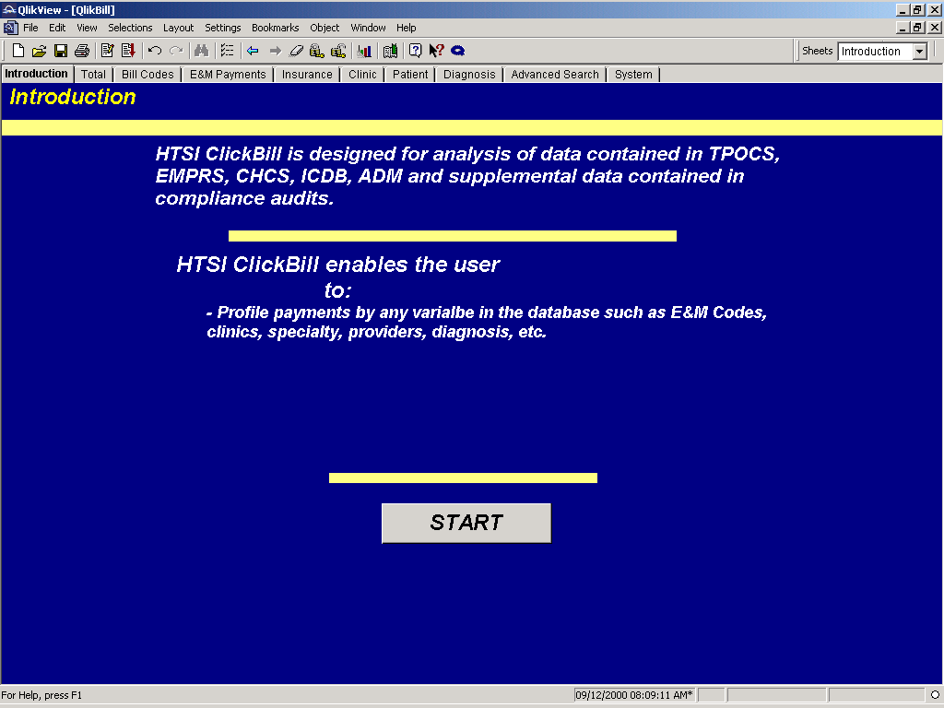

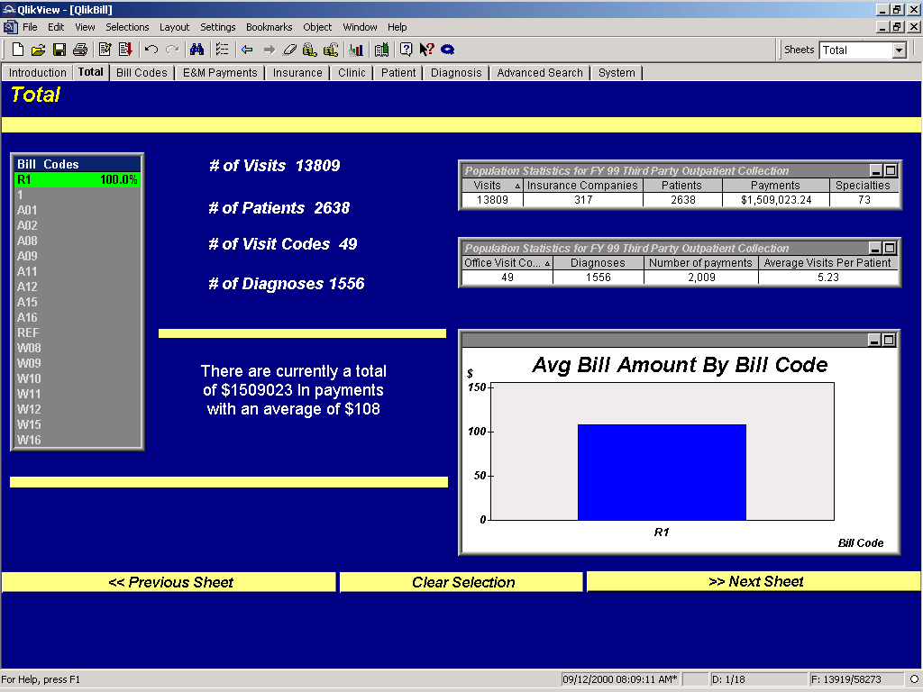
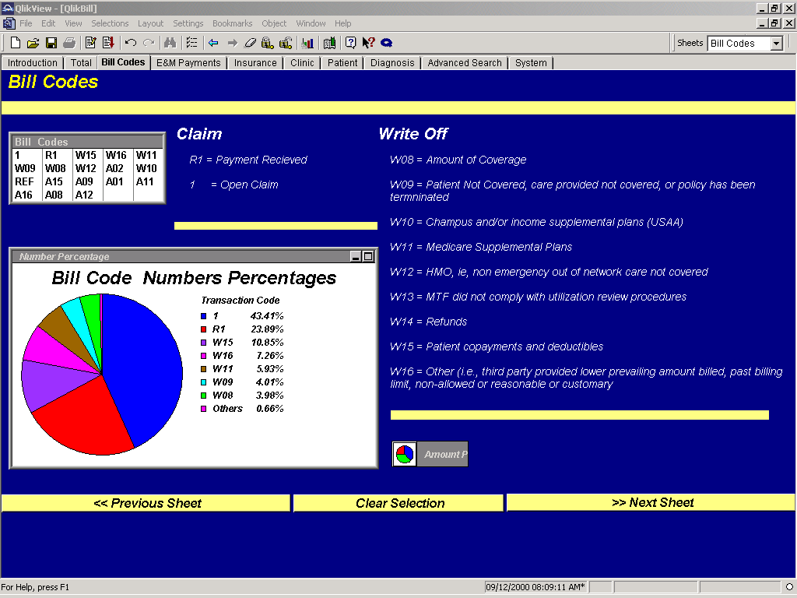
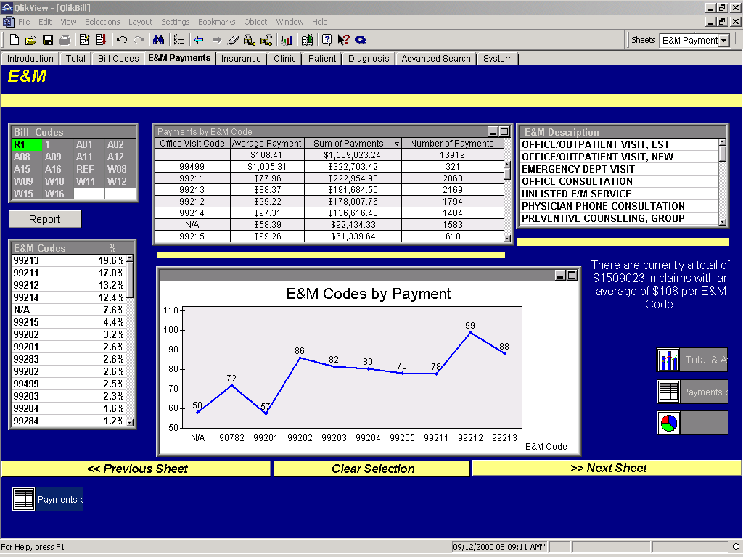
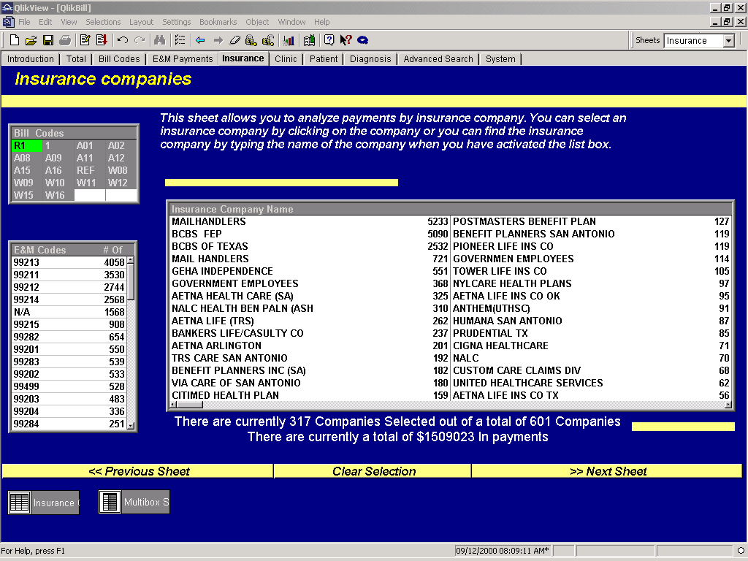

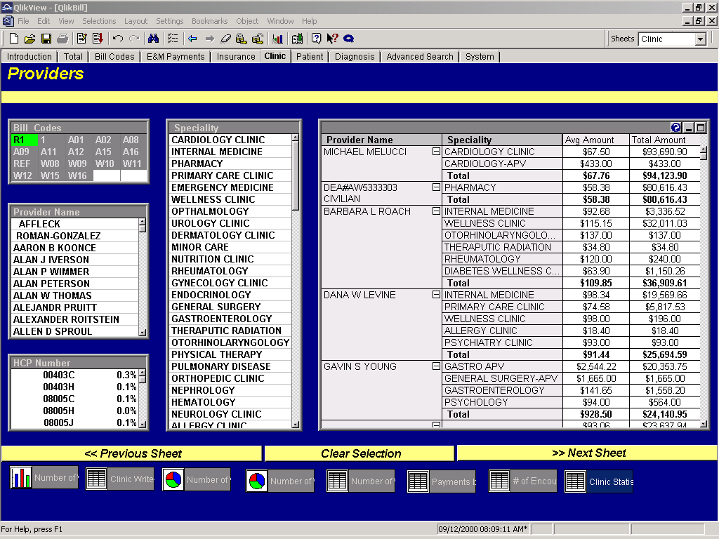
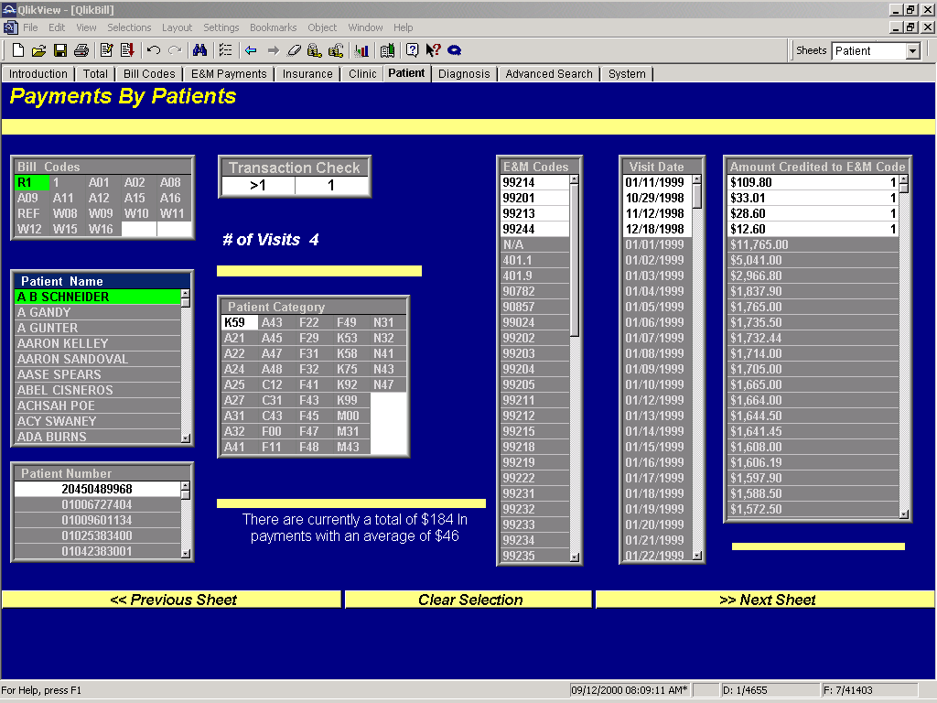
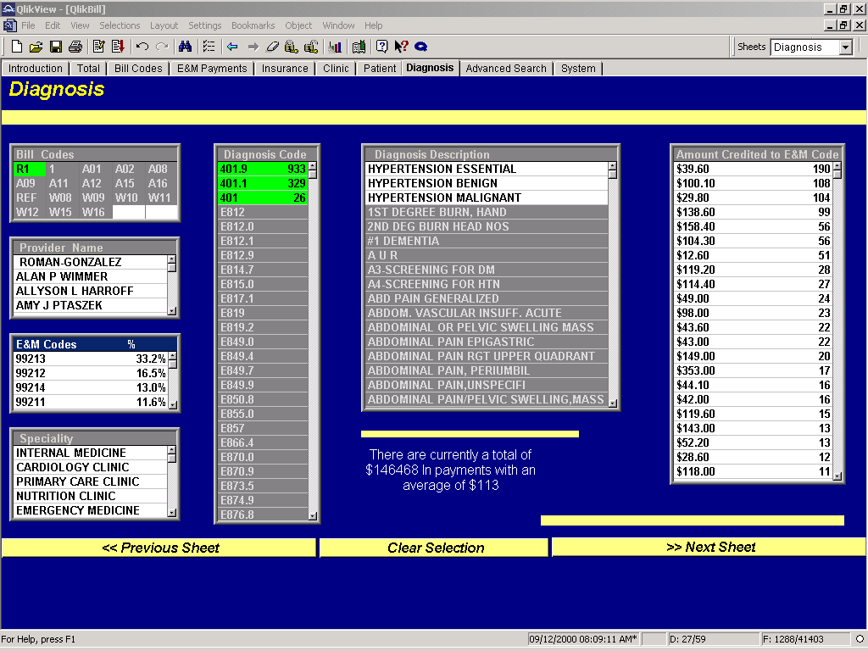
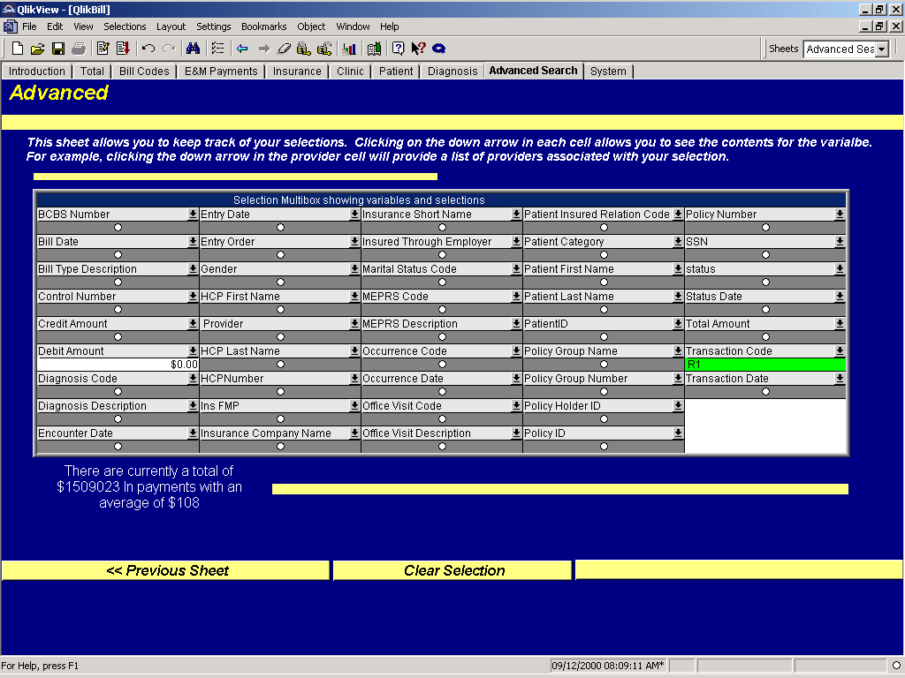

Sample HTSI ClickBill Reports and Queries;
HTSI ClickBill provides the capability to provide reports and queries on any data element loaded from CHCS, ADM, TPOCS, and the PlanetGov/HTSI Database: The following are a couple of examples to demonstrate this capability:

Sample Clinic Report:
The following is a table showing the revenue by MPRS description. All the user has to do is select the clinic statistics graph and the information is loaded to show the latest revenue by clinic. This analysis was done by PlanetGov/HTSI to select the proper placement of insurance claims specialists in the clinics. The data in the table can be sorted any way the user desires. This was sorted based on number of visits.

MEPRS Description | Number of Visits | Average | Total Amount
 | 13809 | $108.41 | $1,509,023.24
CARDIOLOGY CLINIC | 2291 | $71.73 | $165,130.17
PHARMACY | 1540 | $58.39 | $92,434.33
INTERNAL MEDICINE | 992 | $92.13 | $91,856.89
PRIMARY CARE CLINIC | 784 | $80.79 | $63,504.24
UROLOGY CLINIC | 575 | $118.92 | $68,854.75
EMERGENCY MEDICINE | 569 | $121.13 | $69,285.27
OPTHALMOLOGY DEPARTMENT/DIVISION | 516 | $85.75 | $44,591.54
DERMATOLOGY CLINIC | 504 | $58.39 | $29,487.70
WELLNESS CLINIC | 382 | $111.37 | $42,656.49
NUTRITION CLINIC | 363 | $28.11 | $10,259.14
THERAPUTIC RADIATION | 340 | $93.12 | $32,033.77
PHYSICAL THERAPY | 313 | $34.75 | $11,014.17
MINOR CARE | 310 | $116.16 | $36,243.22
RHEUMATOLOGY | 305 | $86.87 | $26,668.66
OTORHINOLARYNGOLOGY CLINIC | 305 | $118.52 | $36,149.55
ENDOCRINOLOGY | 267 | $87.14 | $23,265.12
PULMONARY DISEASE | 240 | $109.06 | $26,175.02
GENERAL SURGERY CLINIC | 235 | $161.38 | $38,246.93
ORTHOPEDIC CLINIC | 232 | $124.87 | $29,095.71
NEUROLOGY CLINIC | 229 | $107.73 | $24,778.66
HEMATOLOGY | 215 | $129.42 | $27,954.38
GASTROENTEROLOGY | 208 | $113.62 | $23,859.77
ONCOLOGY | 172 | $136.75 | $23,658.38
GYNECOLOGY CLINIC | 168 | $113.13 | $19,119.66
ALLERGY CLINIC | 134 | $41.17 | $5,516.87
AUDIOLOGY CLINIC | 132 | $25.65 | $3,436.77
NEPHROLOGY | 128 | $130.32 | $16,681.41
VASCULAR | 124 | $84.84 | $10,604.55
UROLOGY-APV | 106 | $956.40 | $103,290.71
DIABETES WELLNESS CLINIC | 101 | $87.93 | $8,880.92
OPTOMETRY CLINIC | 95 | $47.07 | $4,471.72
PSYCHOLOGY | 91 | $80.66 | $7,420.73
PEDIATRICS CLINIC | 82 | $68.79 | $5,641.18
WOMENS CYTOLOGY CLINIC W | 72 | $114.29 | $8,228.65
GASTRO APV | 68 | $1,142.71 | $77,704.42
CARDIOVASCULAR/THORACIC SURGERY | 54 | $129.11 | $7,101.30
PSYCHIATRY CLINIC | 48 | $104.64 | $5,127.53
GENERAL SURGERY-APV | 46 | $1,120.22 | $51,530.34
PODIATRY CLINIC | 45 | $59.74 | $2,748.03
OCCUPATIONAL THERAPY | 43 | $55.27 | $2,376.73
SLEEP LAB | 35 | $116.04 | $4,061.30
PLASTIC SURGERY | 32 | $125.24 | $4,007.72
NEUROSURGERY | 28 | $217.81 | $6,098.70
OBSTETRICS CLINIC | 27 | $100.89 | $2,724.00
SPEECH PATHOLOGY | 27 | $46.84 | $1,264.68
OB GYN, MHS facility | 24 | $132.61 | $3,182.53
ORTHOPAEDIC APPLIANCE | 23 | $72.52 | $1,668.07
OPTHALMALOGY APV | 19 | $752.30 | $14,293.70
ADOLESCENT | 19 | $76.61 | $1,455.60
ORTHO-APV | 19 | $982.16 | $18,660.95
OTHLARINGOLOGY APV | 17 | $1,105.69 | $18,796.75
PULMONARY-APV | 14 | $678.80 | $10,182.00
BEHAVIORAL HEALTH PSYCH,W | 13 | $104.77 | $1,362.00
PEDIATRIC APV | 11 | $1,443.41 | $15,877.50
AUDIOLOGY | 11 | $22.69 | $249.60
IMMUNIZATIONS | 10 | $17.46 | $174.60
CARDIOLOGY-APV | 9 | $979.03 | $9,790.31
INFECTIOUS DISEASE | 7 | $89.26 | $624.80
CHIROPRACTIC CLINIC | 6 | $25.50 | $153.00
PLASTIC SURGERY-APV | 6 | $1,129.80 | $7,908.60
ALLERGY | 5 | $57.72 | $288.60
BONE MARROW TRANSPLANT | 4 | $148.32 | $741.60
PULMONARY RESP RESOURCE SHARING | 4 | $133.00 | $532.00
GYNCELOGY APV | 3 | $916.33 | $2,749.00
INTERNAL MEDICINCE APV | 3 | $1,062.75 | $3,188.25
ET | 2 | $107.70 | $215.40
AMBULANCE SERVICE | 1 | $26.75 | $26.75
DERMATOLOGY | 1 | $10.91 | $10.91
CHEMOTHERAPY | 1 | $4.80 | $4.80
FLIGHT MEDICINE | 1 | $137.90 | $137.90
OPTHALMOLOGY DEPARTMENT | 1 | $155.20 | $155.20
PODIATRY APV | 1 | $1,235.50 | $1,235.50
VASCULAR SURGERY CLINIC | 1 | $115.54 | $115.54

Sample Report ER Visits:
In the following table we are determining the amount of outpatient Third Party Collection from Emergency Room visits. We created a bookmark so we can analyze this by just simply selecting the bookmark.
The first table shows we selected all the types of ER outpatient visits and the second shows the results of that selection. The bookmark is added just like the ones you set in a Web browser does all this.

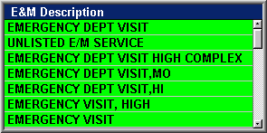

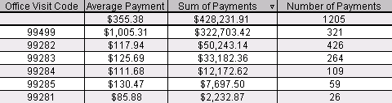

Example Provider Report:
The amount of revenue by provider is important in monitoring the effects of PlanetGov/HTSI education services and may be useful to determine reward programs. The following is a provider revenue table that can be generated by simply selecting the provider revenue graph. Information is updated as of the last reload of information from TPOCS and CHCS – usually on a daily basis.

Top 20 Providers Sorted by # of Visits
Provider # | Specialty | # of Visits | Avg Amount | Total Amount
1 | CARDIOLOGY CLINIC | 1833 | $67.50 | $93,690.90
2 | PHARMACY | 1371 | $58.38 | $80,616.43
3 | WELLNESS CLINIC | 577 | $115.15 | $32,011.03
4 | INTERNAL MEDICINE | 384 | $98.34 | $19,569.66
5 | CARDIOLOGY CLINIC | 316 | $86.02 | $13,418.66
6 | THERAPUTIC RADIATION | 250 | $93.06 | $23,637.94
7 | CARDIOLOGY CLINIC | 237 | $75.08 | $8,184.25
8 | RHEUMATOLOGY | 219 | $88.77 | $15,712.86
9 | PHYSICAL THERAPY | 198 | $34.65 | $6,721.77
10 | PHARMACY | 196 | $58.76 | $11,810.89
11 | WELLNESS CLINIC | 172 | $99.30 | $6,752.56
12 | PRIMARY CARE CLINIC | 168 | $74.58 | $5,817.53
13 | PRIMARY CARE CLINIC | 154 | $83.96 | $5,709.14
14 | CARDIOLOGY CLINIC | 133 | $68.98 | $4,069.98
15 | NUTRITION CLINIC | 131 | $31.46 | $2,925.60
16 | PULMONARY DISEASE | 130 | $128.91 | $13,406.60
17 | PRIMARY CARE CLINIC | 130 | $90.25 | $5,144.10
18 | EMERGENCY MEDICINE | 125 | $122.92 | $8,358.30
19 | EMERGENCY MEDICINE | 123 | $122.68 | $6,992.79
20 | CARDIOLOGY CLINIC | 118 | $96.16 | $5,961.77

Sample Queries:
HTSI ClickBill allows you to drill down using millions of combinations of variables. This can be done by simply clicking on the successive variables of interest or by clicking on data fields in objects such as tables, line charts, pie charts, etc. For example, lets assume you are doing a follow-up on a claim on patient Alene Price with Mail Handlers and they are claiming she did not meet her deductible of $100 for calendar year 1999. You simply select the patient by typing in her name in the patient list box, select Mail Handlers from the insurance company list box and then select W15, the transaction code for deductibles. Immediately you see that deductibles have clearly exceeded $100 in calendar year 1999. The actual total is $623.51 and you can see that not only has Ms Price exceeded the deductible, but also Mail Handlers owes MHS facility $523.51 ($623.51- $100).

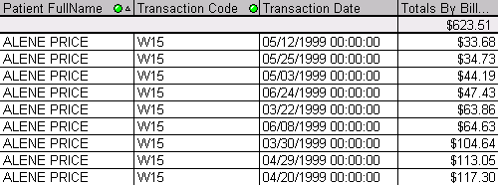

In another example, you want to examine which diagnosis codes are never paid. This could be for a number of reasons so you want to look at them by transaction code. In the following chart lists the top ten diagnosis codes that were not paid. The full table contains 417 codes. This is the table coders and claims specialists would use to determine if the right code was used or if an insurance company may not pay for that code or they are using a black box edit.

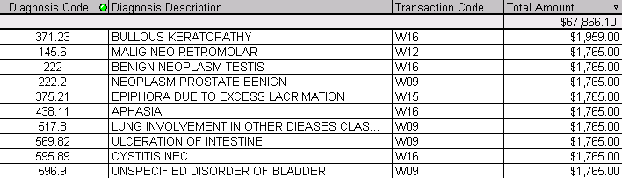

Key Personnel:

The following members of PlanetGov/HTSI will be involved in an intensive effort at start up of the contact and will be routinely making on-site visits to provide management oversight, conduct data analysis, and maintain the data analysis and database software. Detailed information on these team members is provided in the resumes attached to this report.

- Sam Fye – Executive Management Oversight and Data Analysis: Sam Fye is one of the owners of Healthcare Technology Solutions International (PlanetGov/HTSI). He was assigned to MHS on two different occasions. The first time was in Medical Systems and the Division of Nursing. The second time was as the CIO of TRICARE Southwest. After retiring, Mr. Fye was asked to conduct the attached MHS study on Third Party Collection. He has spent well over 1000 hours in analyzing coding and MHS Third Party Collection data and processes and has worked many high level projects in addressing case complexity, reimbursement, and data system installations and maintenance.
- Al Alford – Executive Management Oversight and Knowledge Management: Al Alford is also an owner of PlanetGov/HTSI. Mr. Alford was assigned at Wilford Hall where he was first assigned to the Division of Hospital Services and then as the Executive Officer to the MHS Commander. He is one of the DoD’s leading experts in knowledge management and data movement tools. He will provide operations oversight and will oversee the development and maintenance of the PlanetGov/HTSI WebLibrary tool that will provide access to MHS staff and PlanetGov/HTSI staff for billing reports, performance metrics, policy manuals, and provider performance statistics.
- Laura Sosa - RHIA – Consultant for Round Table Sessions, Consultant for Billing Compliance, and Auditor for Claims Compliance and Coding: Based on her experience with San Antonio insurance companies she will also be assisting in answering coding questions associated with third party insurance claims.. Ms Sosa is one of the country’s leading experts in coding compliance and claims processing. Because of her expertise she was hired by the University of Texas Health Science Center at San Antonio (UTHSCSA) to fix the billing and compliance problems associated with their 17 million dollar fine under the False Claims Act. She was responsible for the follow-on integrity audits and led a staff of 50 coders and claims specialists to achieve an error rate of less than four percent. She is accredited for CME credits and is an instructor at St. Phillip’s College. Ms Sosa is the author of the attached presentation on billing compliance and will be providing the provider education that is accredited for continuing medical education (CME).
- Phillip Bishop – Data Analysis Application Development and Maintenance, Application Training, Database Administration, Develop and Maintenance of Consolidated Billing Report: Mr. Bishop is the world’s leading expert in development of QlikView applications that is the foundation for building the HTSI ClickBill and Provider applications. Mr. Bishop developed all the scripts and applications to extract data from the Wilkes-Barre application and provided the programming support to develop the MHS HTSI ClickBill application. He also developed the program for the consolidated billing report used at the Wilkes-Barre VA. Mr. Bishop will do the initial installation and provide follow-on maintenance for the HTSI ClickBill and PlanetGov/HTSI Provider application. Mr. Bishop will be programmed on site for 16 hours per month to train and support MHS staff with the use of the data analysis and reporting applications. He will be developing all the standard and ad hoc reports required under the SOW.
- Patricia Wagner – RN – Coding Compliance and Care Management: Ms Wagner is a registered nurse and an expert on setting up care management programs (utilization review). Ms Wagner, along with her team of three other registered nurses will be setting up the care management program at MHS for PlanetGov/HTSI. Ms Wagner and her staff are also a certified coders and recognized experts for setting master charge tables for filing insurance claims. She will be our consultant in setting up the required processes to implement the reasonable charges program at MHS as part of the planned migration by the MHS.
- Andrea Maslar – Project Manager and Claims Manager. Ms Maslar is currently the Project Manager for PlanetGov/HTSI’s five million dollar contract with the Wilkes-Barre VA. She set up the operations for Wilkes-Barre to meet the coding, producing the consolidated billing report, records management, invoicing, and data entry into the VA’s billing system (PCE). Ms Maslar was also the Billing Manager for Proworks Occupational Health Management, Manager of Admitting and Patient Registration at Wilkes-Barre General Hospital and Nesbitt Memorial Hospital, and Director of Admissions at Wilkes-Barre General Hospital. She will be brought on site to set up the operations at MHS.
- Mildred Mosella – RHIT – Consultant for Medical Claims and Records Management. Ms Mosella has extensive experience as a consultant with regard to working with insurance companies, attorneys, clients, patients, and insurance contracts. She will be used to address JCAH accreditation issues and addressing medical record issues. She is also a certified coder and will be assisting Laura Sosa with compliance audits.
- Dena Perry – Consultant for Entire Revenue Process. Ms Perry is a certified coder and has lead many projects targeted at revenue enhancement to include audit process for claims specialists and creation and interpretation of payment analysis reports and protocol. She will also be used to assist in setting up protocols for claims follow-up and for insurance company requests for audit.
- Karen Gilbert – RN – Certified Coder, Quality and Care Reviews. Ms Gilbert is a registered nurse who will be assisting in setting up our processes for quality and care reviews. She is also a certified coder and familiar with NCQA guidelines.
- Kathleen Raver – Processing of Billing Data and Claims Specialist. Ms Raver provides expertise from her experience in the Federal Government and Commercial billing systems. She is responsible for processing the coding data for over 45,000 claims at the Wilkes-Barre VA. In her previous job with the Center for Diagnostic Imaging she was responsible for verifying insurance coverage and the accuracy of coding information. Ms Raver will be brought on-site at MHS to assist in the initial set up of the coding and records management database.
- Mariah White-Belt- Claims Processing and Collections. Ms White-Belt provides expertise from her experience in the Federal Government and Commercial billing systems. She provides specific expertise in collection of money owed by insurance companies and patients and accounting and verifying collection of money. Ms White-Belt will be brought on-site at MHS to assist in the initial set up of collection processes and to assist in the set-up of the data entry processes.

Continuity and Quality of New Hires: Revise to make MHS specific
The full time on-site staff will have to be hired from the local area. Since these people will be doing the day-to-day work and provide the daily interface with MHS facility staff and patients, it is absolutely essential that these new staff members be of the highest quality and has the incentives to remain on site throughout the life cycle of the contact. Because PlanetGov/HTSI maintains a low overhead we offer our employees 20% - 25% higher wages than comparable employees in the MTF’s local area. This incentive works very well in getting the highest quality people and keeping them from being hired away from competitors. In addition to the higher wages, we provide a bonus based on the quantity of work performed, the quality of work, and customer satisfaction. Prerequisite to earning a bonus is a quality percent in excess of 95 % and a minimum score of 4.0 on a scale of 1-5 on customer satisfaction surveys. For example, by using this approach, we solved a long-standing problem at the Wilkes-Barre VA where there had constant turn over in staffing provided by other vendors. After 11 months on site there has not been one employee who has voluntarily left our staff. They are a well-motivated staff providing the continuity and experience required to meet our goal of exceeding the customer’s expectations.

references:

PlanetGov/HTSI is very proud of our previous and current performance under contracts with our Government and commercial customers. We encourage you to contact the following references to determine customer satisfaction with our performance.

Wilkes-Barre DVAMC:

The reference that best matches the scope, magnitude, and complexity of the task order requirements under this BPA is the work performed for the Wilkes-Barre Department of Veteran’s Affair’s Medical Center (DVAMC). The Technical Representative to the Contracting Officer is Jeanine Marino. She is the Business Director at the Wilkes-Barre DVAMC. The following is Ms Marino’s contact information and alternative contacts that are also cable of assessing our performance at the Wilkes-Barre DVAMC:

Jeanine Marino
Business Office Director
Phone: (570) 821-7229
E-Mail: Jeanine.marino@med.va.gov

Gina Warnagiris
Billing Department Director
Phone: (570) 824-3521 Ext 7310
E-Mail: Eugenia.Warnagiris@med.va.gov

Terry Milbrodt
Coding Analyst
(570) 824-3521 Ext 7700
E-Mail: Terry.Milbrodt@med.va.gov

The contract at the Wilkes-Barre DVAMC matches your scope, magnitude, and complexity as follows:

Scope: The Wilkes-Barre DVAMC is similar to any large MHS medical center with regard to the inpatient and outpatient care provided and the associated need to code records involving multiple specialties and compliance issues associated with residency programs. In addition, the Wilkes-Barre DVAMC provides nursing home care that is part of the contract coding requirement. Specifically, the Department of Veteran’s Affair’s Medical Center Wilkes-Barre, Pennsylvania is a General Medical and Surgical facility consisting of 116 operating hospital beds, 173 nursing home beds, and 10 Substance Abuse Residential Rehabilitation Treatment Program (SARRTP) beds. This facility serves veterans throughout northeastern and central Pennsylvania and southern New York State and is affiliated with Hahnemann University Hospital, the MCP Hahnemann School of Medicine and the Pennsylvania College of Optometry. There are presently 59 residents in established residency programs at this Medical Center, 54 in Internal Medicine, 2 in Ophthalmology, 2 in Dental, and 1 in Optometry. Additionally, there is 1 Pulmonary Fellow also in training. The facility also supports over 55 affiliations with other colleges, universities, and schools of allied health. Ambulatory care services are provided through a variety of outpatient clinics conducted in Wilkes-Barre, Pennsylvania and at satellite outpatient clinics located in Allentown, Sayre, Williamsport, Tobyhanna, and Schuylkill county, Pennsylvania. Several special programs offered at the Wilkes-Barre, Pennsylvania facility include: A Hemodialysis Unit, Cardiopulmonary Rehabilitation Program, Outpatient Post-Traumatic Stress Disorder Program, Home Based Primary Care, Mental Hygiene Clinic, Polysomnography Laboratory, Short Procedures Unit, Same Day Surgery Program, Women’s Health Program, Step-Down Unit, 23 Hour Observation Beds, Substance Abuse Residential Rehabilitation Treatment Program (SARRTP), Halfway House, and Visual Impairment Services. The extended care program encompasses a Nursing Home Care Unit, a Geriatric Evaluation and Management Program, a Subacute Unit, a Hospice Unit, and Respite and Residential Care Programs. The facility also provides HIV, Persian Gulf, Ex-POW, sexual abuse and spiritual counseling as well as psychological testing, and behavior management modification.

Magnitude: We code all the inpatient discharges to include the nursing home. For outpatient care, we code all records that are identified as claims for third party insurance. We code for all the specialties offered at the Wilkes-Barre DVAMC and for all the satellite facilities. Full time on-site coders are located at Wilkes-Barr, Allentown, and Sayre. Our coders also make on-site visits to the other facilities listed below. When on-site at remote facilities they are capable of remote access to the Wilkes-Barre information systems using notebook computers. The following charts are extracts out of the HTSI ClickBill application showing the volume of records coded by record type and by facility:

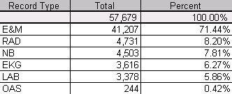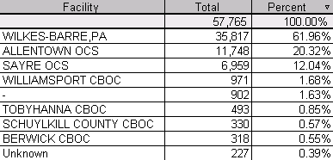

Complexity: We provide the following services under our coding services contract with the Wilkes-Barre DMAMC. We believe they demonstrate that we have experience in all phases of the services required in your task order.

- Certified Coders: We have nine certified coders that code records at the Wilkes-Barre DVAMC on either a full time or part time basis. Seven code outpatient records and two code inpatient records. Of the Seven outpatient coders, we have one full time coder at Allentown and one at Sayre. We handle all the complexities associated with coding records for multiple specialties and multiple facilities. We have a mix of very experienced coders – two are RNS, two are RHIAs, one RHIT, and four CPCs. The average years of experience for these coders exceeds 10 years.

- Program Management: We have a full time Program Manager on site with 18 years management experience in multiple healthcare settings ranging from clinics to major medical centers. This individual is our direct contact with the customer and provides support for reports, invoices, training, security, staffing, and computer applications. This individual is a non-coder and is fully dedicated to program management responsibilities.

- Records Administration: We have three full time administrative assistants with each having numerous years experience in physician offices. They do the abstracting for inpatient coding, pull records for the Allentown facility, maintain a filing system and associated data base for the 60,000 coded records, do data entry into the DVAMC’s hospital information system (VISTA), and provide data validation.

- Senior Systems Analyst: A senior systems analyst spends two days on site every month to design, program, and maintain reporting and decision support software designed to convert clinical and coding data into useful information. The HTSI ClickBill application is used to improve third party revenue and to increase the efficiency of the Coding and Billing Department. This software will be discussed in detail later.
- Senior Consultant: A senior consultant spends two days a month on site working directly with the coding staff and the DVAMC staff to review and report performance with regard to revenue objectives and compliance with contract specifications. This senior consultant also addresses any problems or issues that have not been solved by the on-site Program Manager.

- Senior Auditor: An independent auditor comes on site once a quarter to provide an external audit of the contract coders. This is in addition to the internal audits conducted on-site on a weekly basis. Based on audit findings the senior auditor provides training to the contract coders and any DVAMC staff who wish to attend.

- Senior Trainer: The senior auditor is usually the senior trainer. Using the HTSI ClickBill application, the auditor is provided with specific specialty, provider, and facility information coding accuracy and reasons not billable to conduct a problem focused training approach targeted at specific providers, specialties, and facilities. In addition to this problem-focused training, general sessions are provided to improve documentation in the provider note and provide instruction on teaching physician guidelines. This is CME accredited training. We assist the education department by providing lesson plans, completing attendee lists, and providing copies of our Power Point presentations.

Assistant Secretary of Defense, Health Affairs:

We use a number of software tools that give us a competitive advantage in the program management aspects of coding service contracts. In addition to our HTSI ClickBill application we use our Web Library and data movement tools to enhance the distribution of coding knowledge, distribute and track key documents, and to provide a state of the art communications infrastructure. Our past performance reference for the Web Library and the data movement tools is:

Marco Johnson
Program Management of Health Information Resources Service
5109 Leesburg Pike, Falls Church VA 22041
Phone: (703) 681-8780
E-Mail: marco.johnson@tma.osd.mil

Integrated Outcomes:

Integrated Outcomes is a reference for our ability to analyze and report clinical, coding and billing information in the commercial sector. Under our contract with Integrated Outcomes we associate laboratory, patient, claims, pharmacy, and provider data with ICD 9CM and procedural codes for WellMed, a large HMO in San Antonio Texas. The application produced for WellMed allows a user to select an individual diagnosis code or a major diagnosis category and profile this information by medications, insurer, specialty, laboratory results, adverse events, claims, provider, or any other variable available in in the WellMed clinical databases. The contact at Integrated Outcomes is:

Jim May
CEO
Integrated Outcomes
Phone: (972) 675-2445
E-Mail: jmay@ioutcomes.com

Wilford Hall Medical Center:

The attached study demonstrates our understanding of the Third Party Collection issues at a large MHS facility and our ability to understand and make recommendations in a very complex environment .

Lieutenant Colonel Steve Wolf
Phone: (703) 575-2387 or
E-Mail: Stephen.Wolfe@tma.osd.mil.

Wilford Hall Medical Center:
This was an unsolicited proposal for records management. The proposal demonstrated our understanding of the complex issues associated with records management and the potential effect these issues have on Third Party Collections and ability to meet JCAH requirements.

Ms Hattie Wright
Phone: (210) 292-5779
E-Mail: hattie.wright@lackland.af.mil

Electronic Paper Solutions

This project we provided services to EPS to assist them in reviewing medical records processes and the review of IDX Billing System at Fallon Clinic – a large HMO located in Worcester, Massachusetts. In this project we extracted appointment scheduling information and claims data for the purpose of analyzing missed billing opportunities and to profile bad debt patients. The resulting application allowed EPS to help Fallon profile the use of diagnosis codes and CPT codes by provider, specialty, HMO membership, payments, processing times, etc. The contact for our work for EPS is as follows:

Arthur Fitzgerald
Electronic Paper Solutions (EPS)
Pine Brook Dr, Peabody, MA 01960
(978) 535-5556
E-Mail: epsinc203@aol.com

Sequence of Events:

PlanetGov/HTSI will take a systematic approach to performing the tasks proposed in the technical proposal. We realize the first priority is to take immediate action to meet MHS facility’s expectation for revenue growth. To that extent, the first order of business will be to catch up the backlog of medical records that need to be coded, ensure compliance, and the immediate use of the HTSI ClickBill application to monitor coding processes and to identify billable visits and admissions in CHCS. This will drive the revenue gains that provide a positive return on investment with the coding services contract. Shortly thereafter we will begin provider training and reporting activities.

point of Contact for Technical Proposal:

We would be glad to answer any questions concerning this proposal, present on our capabilities, or provide a demonstration of our software products. Our point of contact is Sam Fye. He can be reached by phone at (830) 606-4918 or by E-Mail at SFYE@satx.rr.com,

Operations Management, Continuous Improvement, Schonberger & Knod

